Starting with Bold for Delphi/Bold for C++
Part 2: Extending Models

Anthony Richardson - anthony@viewpointsa.com
2 August 2002, Revision 1.1

All trademarks are properties of their respective holders. All intellectual property claims are respected. The publication is copyright 2002 by Anthony Richardson. Anthony Richardson grants BoldSoft MDE AB a royalty-free non-exclusive license to distribute this publication worldwide.

I would like to acknowledge the assistance of BoldSoft MDE AB in the creation of these articles. Especially the assistance of Jesper Hogstrom, Jonas Hogstrom and Dan Nygren, without their support this project would not have been possible.
Contents
Starting with Bold for Delphi/Bold for C++ 1
Getting Started 3
Introduction 3
Contacting Anthony Richardson 3
Contacting BoldSoft 3
Extending Models 4
Example Application 4
Build Basic Project 5
Build the Model 6
Generating Pascal Code 10
Adding a User Interface 11
Running The Application 15
Using Code in Bold Applications 18
Enhancing the application with code 18
Introduction to Object lifecycles 20
Using Delphi Code 20
Model driven object life management 21
Derived & Reverse Derived Attributes 23
Adding the new attributes 23
Reversed Derived 25
Derived Attributes with OCL 27
Operations 29
Adding an Operation 29
Derived Relationships 33
Adding the Managed By relationship 34
Adding the Workforce relationship 35
One-way Relationships 36
Constraints: A parting note 42
Summary 42
Appendix A: Source Code 43
Instructions 43
HRManager.dpr 44
MainForm.pas 45
MainForm.dfm 48
BusinessLayer.pas 56
BusinessLayer.dfm 57
HRClasses.pas 63
HRClasses.inc 72
HRClasses_Interface.inc 74

Getting Started

Introduction
‘Starting with Bold for Delphi’ is a series of articles design to provide an introduction to the Bold for Delphi product and effective techniques for applying the Bold framework in the development of real world applications.

These articles are designed as an introduction. The Bold for Delphi product contains many components and is comprised of 1765 classes spread across over 665 units. The product contains many sub frameworks within these classes to support advanced development techniques and the application of industry best practices in the form of patterns, interfaces and modeling.

The design of Bold for Delphi is carefully layered to enable rapid adoption of core techniques with the gradual adoption of the more complex or sophisticated methods as required. These articles are designed to facilitate the transition from traditional programming to the core Bold for Delphi techniques.

Contacting Anthony Richardson
All feedback on this article is welcome:

Email: anthony@viewpointsa.com

Web: http://www.viewpointsa.com

Contacting BoldSoft
Getting help with using Bold for Delphi is available from BoldSoft.

Email: support@boldsoft.com

Web: http://www.boldsoft.com

Extending Models

Example Application
To begin the journey into more advanced modeling techniques we will start with a model for a basic Human Resource Management Application.
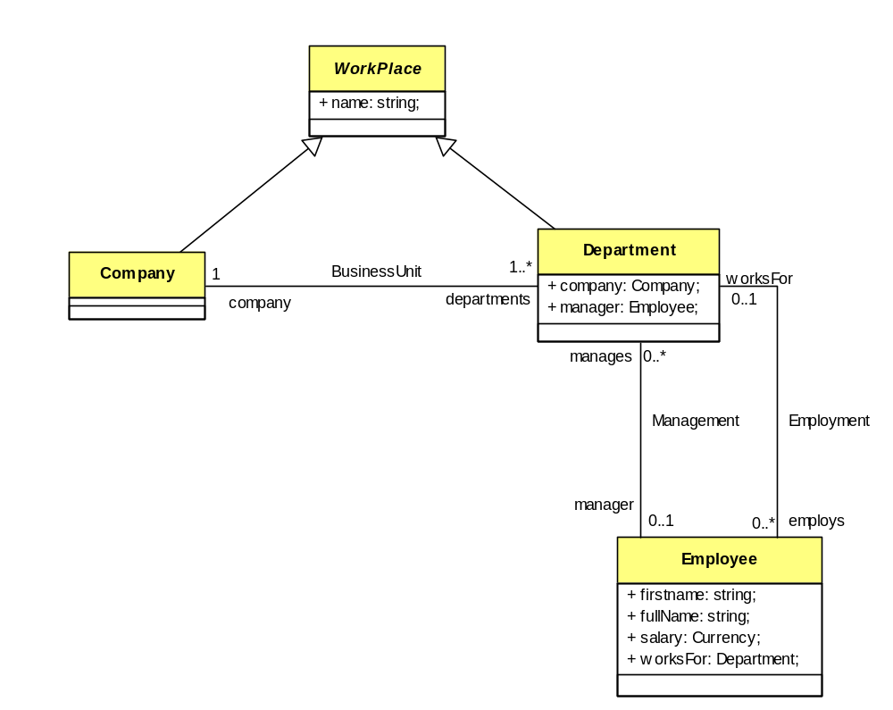
Figure 1: Basic Class Model
The first article in this series covered the construction of a basic model. The concept of classes, attributes and relationships was discussed. In Figure 1 no new concepts are introduced and the following basic business rules are enforced:
- We have Company and Departments, which are types of Workplace.
- We have Employees, which can work for a department
- Companies can contain Departments.
- A Department can have one manager, which is an Employee.
- An Employee can manage multiple departments

We will step through the creation of this with a basic GUI quickly so we can get to the real interesting modeling concepts sooner.

Build Basic Project

Groundwork
To get started we need to setup a basic Delphi project with a data module.
- Select File|New Application from the Delphi menu.
- Save the Form unit as MainForm.pas and the project as HRManager.dpr
- Add a new Data Module by selecting File/New and selecting Data Module from the New Items Dialog.
- Set the Data Modules name to BusinessModule.
- Save the DataModule as BusinessLayer.pas.

Models, Handles and Persistence
To prepare the application to accept a model, do the following:
- From the Bold Handles component tab add a BoldModel, BoldSystemTypeInfoHandle and BoldSystemHandle to the Data Module.
- Link the BoldModel property from BoldSystemTypeInfoHandle1 to BoldModel1.
- Link the BoldSystemTypeInfoHandle property from BoldSystemHandle1 to BoldSystemTypeInfoHandle1.
- From the Bold Persistence component tab add a BoldPersistenceHandleFileXML component to the data module.
- Link the BoldModel property to the BoldModel component.
- Link the PersistenceHandle property of BoldSystemHandle to the BoldPersistenceHandleFileXML component.

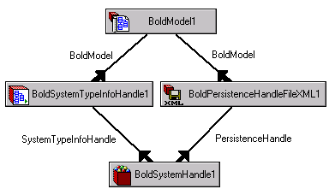

Basic configuration Changes
Initially in this example application we will use the following property values, set these in the Delphi property editor:

Component: BoldSystemTypeInfoHandle1
Property: UseGeneratedCode
Value: True
This allows us to work directly with the model using Object Pascal.

Component: BoldPersistenceHandleFileXML1
Property: FileName
Value: HRData.XML

Component: BoldSystemHandle1
Property: AutoActive
Value: True
This property results in the BoldSystemHandle1 opening the XML file and being ready for immediate use on application startup.

Add the following event handler for the data module’s OnDestroy event:

procedure TBusinessModule.DataModuleDestroy(Sender: TObject);
begin
BoldSystemHandle1.System.UpdateDatabase;
end;

This ensures that any information entered at runtime will be saved to the XML file.

Build the Model
Double click the BoldModel component to open the Bold UML Model Editor. Set the model name to HRClasses as per Figure 2. Change models Unit name to HRClasses and Model root class value to HRClassesRoot. Change the BusinessClassesRoot classes name to HRClassesRoot.

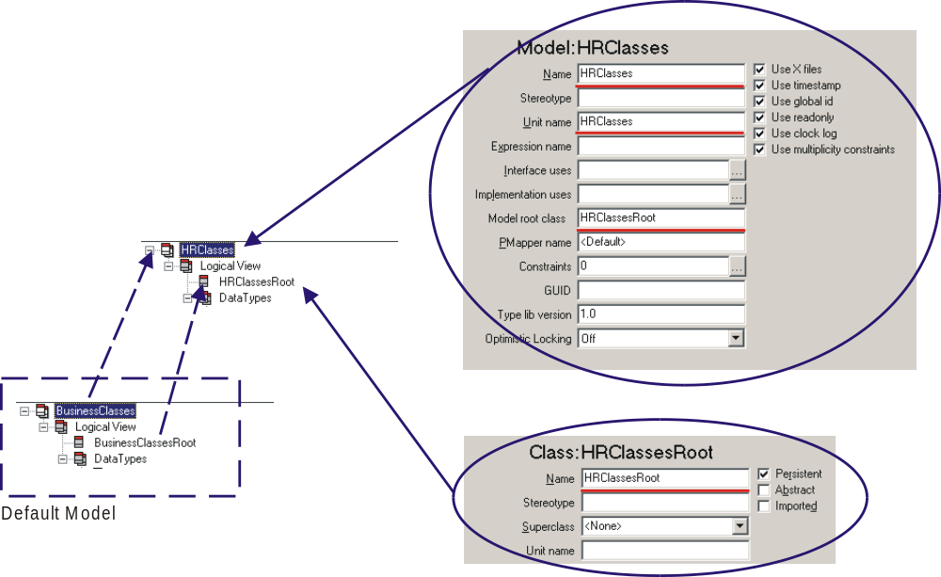
Figure 2: Model Properties

Changing the model’s default values above should become a habit. Leaving the default names may cause problems in future projects. When generating source code Bold for Delphi will search the current project directory, directories of other files in the project and the Delphi search path for files matching Unit name. If the file is found it will be overwritten. This is the desired behavior if the file is for the current project but can cause problems if working with multiple models in related projects.

For the reason given above it is also a good idea to ensure the project is saved to a directory before generating code from your model.

Construct the classes and set the properties as indicated:

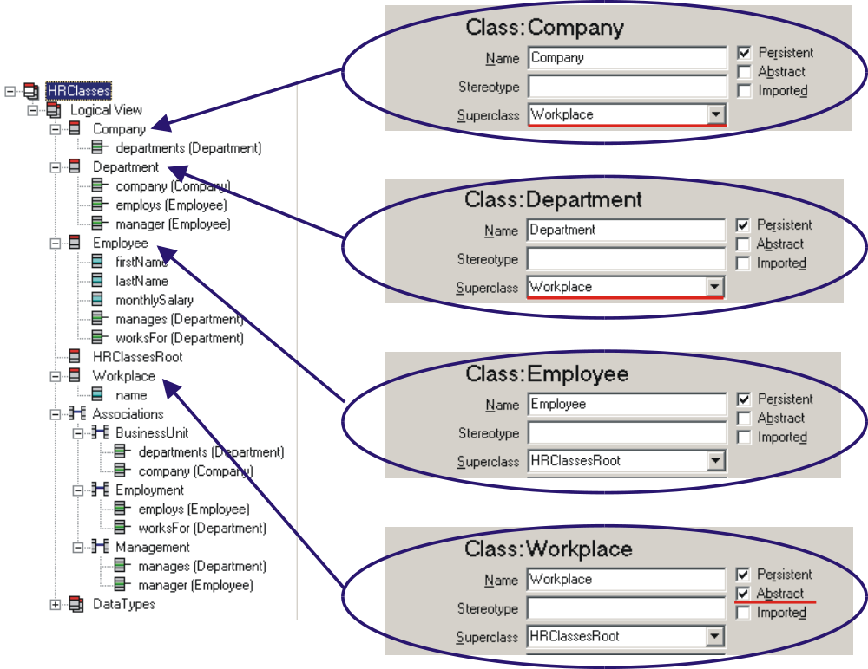
Figure 3: Basic Classes
And the attributes:
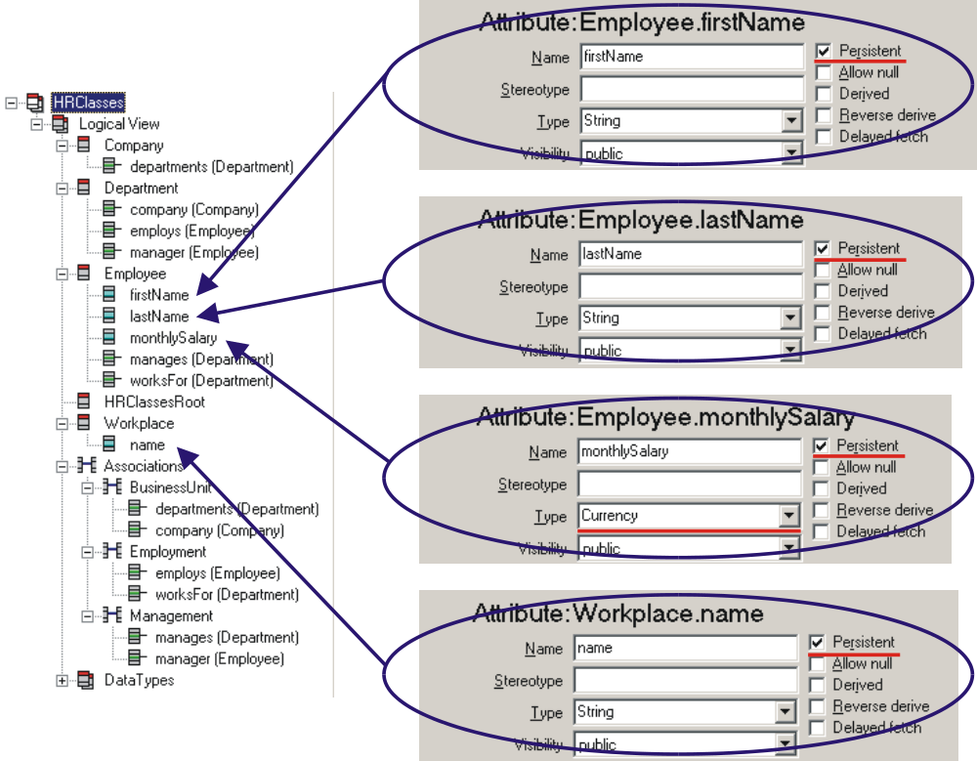
Figure 4: Basic Attributes
And the associations:
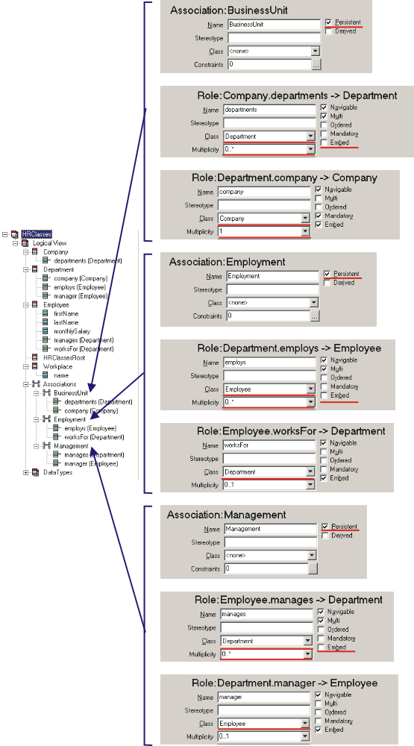
Figure 5: Basic Associations

Generating Pascal Code
In the Bold UML Model Editor select Generate Code from the Tools menu. You will be prompted to confirm or change the default include file created to hold class definitions. Accept the default, HRClasses_Interface.inc name. You will then be prompted with a name for the unit to store class information, again accept the default.

The generated code files will be loaded into the Delphi code editor as in Figure 6. The use of include files in Bold for Delphi is to ensure that code completion works correctly. The generated code files (*.pas & *_Interface.inc) should not be altered, as they will be overwritten on next code generation. Other generated code files (*.inc, excluding *_Interface.inc) will only be appended to; these are generated when using operations or derived attributes/relationships.

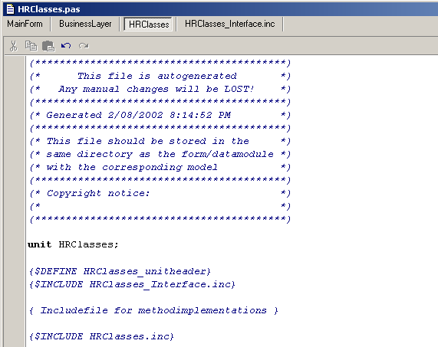
Figure 6: Generated Code

It is interesting to have a look at the generated classes.

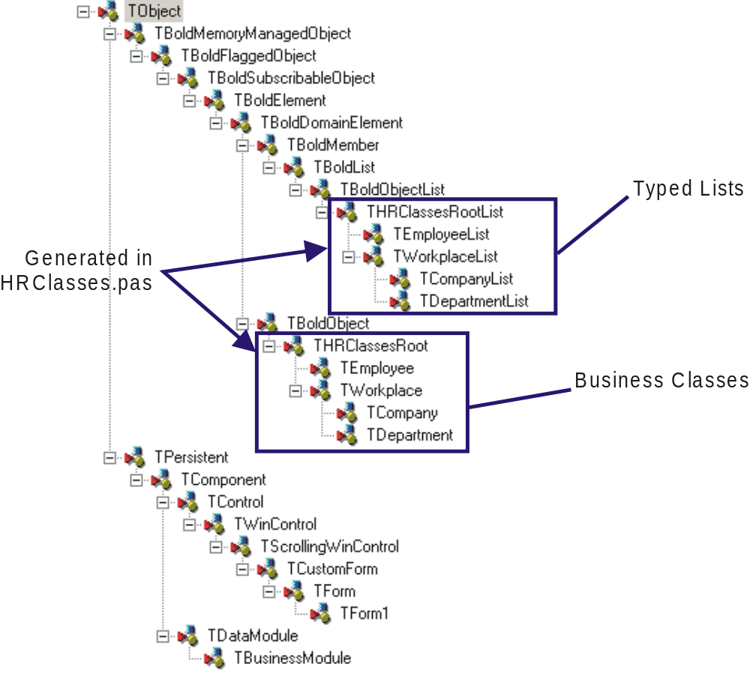
Figure 7: Class Hierarchy

Figure 7 shows the class hierarchy for the project. The classes marked in a blue outline are the auto-generated classes in HRClasses.pas. You will notice for each class created that Bold for Delphi automatically creates a matching typed list. This allows for clean code when working with lists of objects and multi-relations, the full benefit of compiler type checking is available to your code. Bold for Delphi also maintains the model hierarchy allowing for normal Delphi class comparisons when working with objects in code.

Adding a User Interface

Simple Main Form
To get the application up and running as soon as possible we will build a simple main form allowing us to edit the business objects. This will allow for testing of the design and a demonstration of a few Bold for Delphi features.

To the MainForm.pas unit add BoldAFPDefault and BusinessLayer to the uses clause. The BoldAFPDefault unit allows Bold for Delphi to automatically generate editor forms for the business objects that can be launched automatically from Bold-aware controls. The BusinessLayer unit allows the Bold-aware Controls to see the model on the data module.

From the Bold Handles component palette add 4 BoldListHandle components to the form. From the Bold Controls component palette add 4 BoldNavigator components and 4 BoldGrid components. Also add 4 standard Delphi Label & Bevel components to help keep everything in order.

Use the following layout to position the controls. The caption of each label has been set to describe the control:

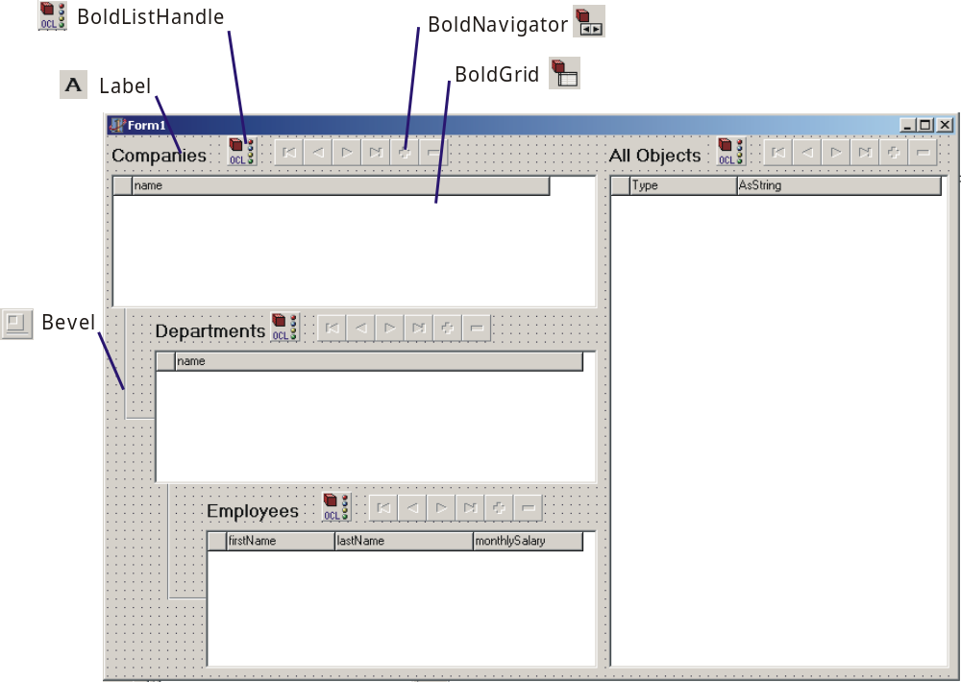

For each group of controls set the following properties:

Companies

BoldListHandle
Name: CompanyList
RootHandle: BusinessModule.BoldSystemHandle1
Expression: Company.allInstances
Enabled: True

BoldNavigator
Name: CompanyNavigator
BoldHandle: CompanyList
Enabled: True

BoldGrid
Name: CompanyGrid
BoldHandle: CompanyList

After setting the BoldHandle property, right-click on the grid and select Create Default Columns from the context menu.

Departments

BoldListHandle
Name: DepartmentList
RootHandle: CompanyList
Expression: departments
Enabled: True

Using the CompanyList handle as the root handle allows the DepartmentList handle to create a master detail relationship. The expression department means that this list will automatically contain all departments linked to the currently selected company.

BoldNavigator
Name: DepartmentNavigator
BoldHandle: DepartmentList
Enabled: True

BoldGrid
Name: DepartmentGrid
BoldHandle: DepartmentList

After setting the BoldHandle property, right-click on the grid and select Create Default Columns from the context menu.

Employees

BoldListHandle
Name: EmployeeList
RootHandle: DepartmentList
Expression: employs
Enabled: True

Using the DepartmentList handle as the root handle allows the EmployeeList handle to create a master detail relationship. The expression employs means that this list will automatically contain all employees employed by the currently selected department.

BoldNavigator
Name: EmployeeNavigator
BoldHandle: EmployeeList
Enabled: True

BoldGrid
Name: EmployeeGrid
BoldHandle: EmployeeList

After setting the BoldHandle property, right-click on the grid and select Create Default Columns from the context menu.

All Objects

BoldListHandle
Name: ObjectList
RootHandle: BusinessModule.BoldSystemHandle1
Expression: HRClassesRoot.allInstances
Enabled: True

BoldNavigator
Name: ObjectNavigator
BoldHandle: ObjectList
Enabled: True

BoldGrid
Name: ObjectGrid
BoldHandle: ObjectList

After setting the BoldHandle property, right-click on the grid and select Create Default Columns from the context menu.

Running The Application
When you run the application add some entries for Company, Department and Employees. The main form will look similar to Figure 8.

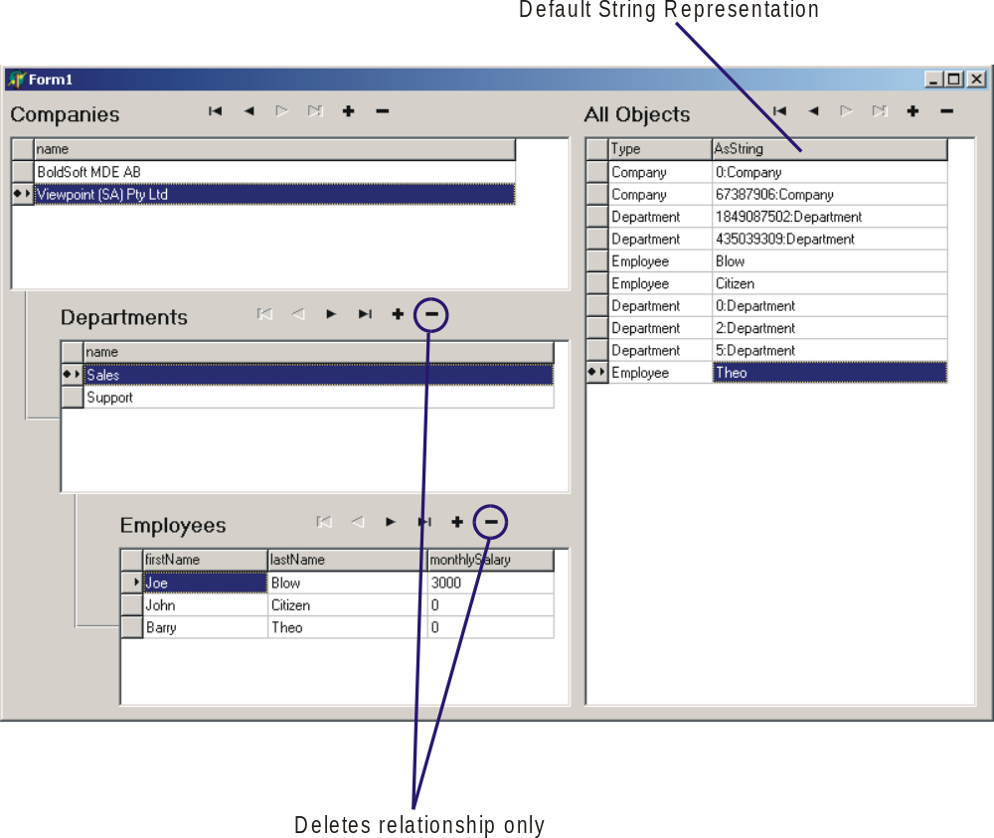
Figure 8: Basic Application at Runtime
When you add a new department, using the BoldNavigator, Bold for Delphi will automatically establish the relationship with the company, likewise adding employees adds the relationship to departments. When you delete from the Company grid or the All Objects grid the object is deleted. When you delete from the Department or Employee grid the object is not deleted, but the relationship is unlinked. This change in behavior is the default when you cascade list handles. This can be changed by altering the BoldDeleteMode property of the TboldNavigator. It is possible to set this to dmUnlinkAllandDelete to force the actual deletion of the object.

Double clicking a row will open the default editor for that object and allow drag and drop relationship linking.

The all objects grid is interesting; here Bold for Delphi has created a column to display the type of the object and a column to display the object ‘AsString’. The AsString column is the string representation of the object. In the example Bold for Delphi has automatically used the lastName of employees to represent them but has created a mangled string for both companies and departments. The reason for this is both the company and department classes don’t have any attributes (they rely on inheritance). Since this is confusing we can tell Bold for Delphi how to represent the objects in a more human readable way.

Default String Representation
Figure 9 shows the settings for each class. By using an OCL expression a human readable identifier can be created for each class.

For the Company class we simply use the company name as inherited from the Workplace class. For Department we grab the name of the company associated with the department, add a hyphen and append the department name. For the Employee class the aggregation of the firstName and lastName are used.

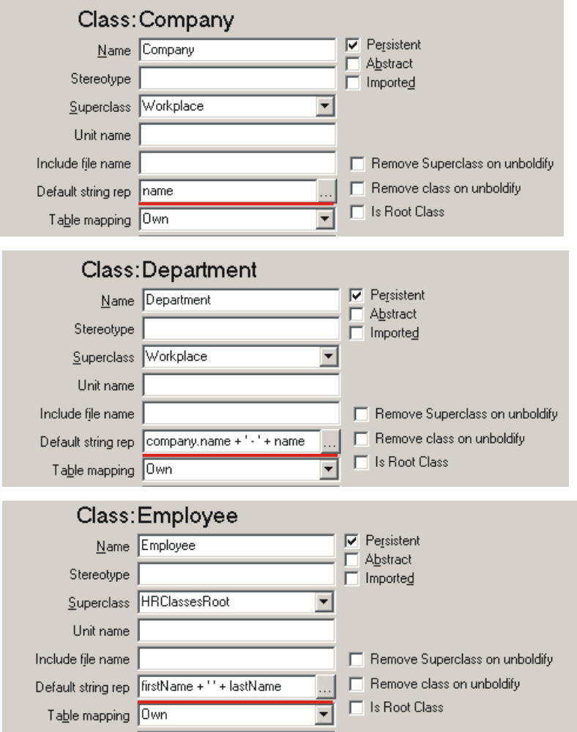
Figure 9: Setting Default String Representation
This results in a much more readable display as shown in Figure 10.

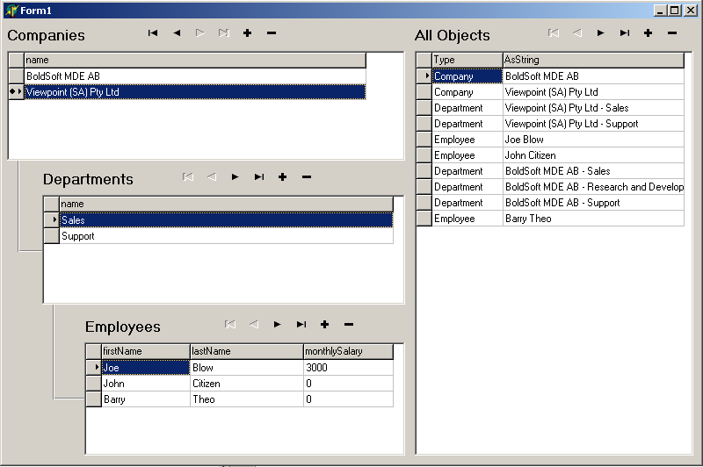
Figure 10: Application at Runtime (with readable object string representation)

Before we move in to write Pascal code let’s add a new column to the department grid and display the manager for the department.

- Right-click the DepartmentGrid and select ‘Edit Columns’.
- Add a new column in the column editor
- Set the BoldProperties.Expression parameter to ‘manager’ (without the quotes).

Now when you assign a manager to the department the employee will be displayed in the grid. Because the result of the expression manager actually returns an employee object, the TBoldGrid will actually use the employee classes Default String Representation set earlier. This results in the employee’s full name being displayed in the grid. (Hint: Use the default forms and drag and drop to set the manager for a department)

Using Code in Bold for Delphi Applications
Yet another powerful aspect of Bold for Delphi is the ability to use native Pascal objects for your business objects. When using traditional database programming the data has no type within the code you are writing (except for basic types like string or integer). When using the Generate Code functionality of Bold for Delphi you can use native Delphi classes that wrap the Domain Classes you have created in the Bold UML Modeler.

The benefits of being able to do this are enormous in terms of:
- Code readability.
- Code maintainability.
- Code accuracy.
- Development speed.

When coding with Bold for Delphi you inherently gain the benefit of Delphi’s strong type-checking compiler. Delphi’s integrated code editor prompts you with all your classes’ information via code completion. You code reads closer to the level of intent of what you are trying to achieve, that means your code is a lot closer to becoming self documenting.

Enhancing the application with code
We are going to add a pop-up menu to the employee grid and add the ability to delete, add new and promote an employee to manager.

- Add HRClasses to the MainForm’s unit uses clause. This is required to allow use of your domain classes in the main form.
- Add a TPopupMenu component to the form and set it’s name to EmployeePopupMenu.
- Set the EmployeeGrid’s PopupMenu property to this new popup menu.
- Add a menu item to the popup menu with the caption ‘Make Manager’.

This sets up the basic framework for adding our code. Begin by setting the EmployeeGrid’s OnContextPopup event with the following code:

procedure TForm1.EmployeeGridContextPopup(Sender: TObject;
MousePos: TPoint; var Handled: Boolean);
var
EmployeeAssigned: Boolean;
begin
// Enable/Disable Menu items depending if an Employee is
// selected.
EmployeeAssigned := EmployeeGrid.CurrentBoldElement is TEmployee;
MakeManager1.Enabled := EmployeeAssigned;
end;

This code controls the availability of the popup menu item depending on if an object is available in the appropriate grid. If no object is selected in a grid the grid’s CurrentBoldElement property will return nil. If an object is selected this property will return that item as a TBoldElement, this is a base class for all classes created from the model, and all lists of classes as well. (Refer to Figure 7 from earlier in this article).

Add an OnClick event handler for the ‘Make Manager’ menu item.

procedure TForm1.MakeManager1Click(Sender: TObject);
var CurrentEmployee: TEmployee;
begin
// Check that the object is an Employee object and
// assigned it to our local variable
if EmployeeGrid.CurrentBoldElement is TEmployee then
begin
CurrentEmployee := TEmployee(EmployeeGrid.CurrentBoldElement);

// Check if the employee works for a department and set the
// employee as the manager
if assigned(CurrentEmployee.worksFor) then
CurrentEmployee.worksFor.manager := CurrentEmployee;
end;
end;

The comments in the code should be almost unnecessary. The power of working with native Pascal code is evident. Even the mundane task of validating the selection is simplified using the Delphi is operator and a typecast to a local variable. The shear simplicity of using a statement like ‘CurrentEmployee.worksFor.manager := CurrentEmployee’ in terms of maintainability and readability is incredible. This can be read as ‘For the current employee, set the manager of the department for which they work to that employee’.

It would be good object orientated design to move this code into the Employee class as an operation call Promote. Then any error checking would be encapsulated in one location and any business rules about managing the promotion process is abstracted from the presentation layer.

Introduction to Object lifecycles
Many Bold for Delphi controls support the creation and deletion of objects, for example the BoldNavigator used in the example application. Other methods exist to work with object creation and deletion as well. By using Delphi Code you can add special creation code to class operations or derived attributes, make use of the code in general GUI code, like buttons OnClick events. Bold for Delphi also supports options within the model itself to help manage an objects lifecycle.

Using Delphi Code
Add two more menu items to the employee grid’s popup menu with the captions ‘Add New Employee’ and ‘Delete Employee’.

Enhance the previously created Context Popup event of the Employee grid to include the following:

procedure TForm1.EmployeeGridContextPopup(Sender: TObject;
MousePos: TPoint; var Handled: Boolean);
var
EmployeeAssigned: Boolean;
begin
// Enable/Disable Menu items depending if an Employee is
// selected.
EmployeeAssigned := EmployeeGrid.CurrentBoldElement is TEmployee;
MakeManager1.Enabled := EmployeeAssigned;
DeleteEmployee1.Enabled := EmployeeAssigned;

// Enable/Disable Menu items depending if a department is selected.
AddNewEmployee1.Enabled :=
DepartmentGrid.CurrentBoldElement is TDepartment;
end;

Add on OnClick event handler for the ‘Add New Employee’ menu item:

procedure TForm1.AddNewEmployee1Click(Sender: TObject);
var NewEmployee: TEmployee;
CurrentDepartment: TDepartment;
begin
// Because the Context Pop-up code has already checked
// that the current element is a TDepartment we can
// typecast to TDepartment safely
CurrentDepartment := TDepartment(DepartmentGrid.CurrentBoldElement);

// Create a new Employee object
NewEmployee := TEmployee.Create(CurrentDepartment.BoldSystem);
// Set the department of the new employee to the current
// department
NewEmployee.worksFor := CurrentDepartment;
end;

The key concept from this code is the ease of creating a new object; just create an instance of the class like any other Delphi object. Of course then you can proceed to use that object however you like.

Deleting an object is just as easy; add the following code to the OnClick event of the ‘Delete Employee’ menu item:

procedure TForm1.DeleteEmployee1Click(Sender: TObject);
var CurrentEmployee: TEmployee;
begin
// Check that the object is an Employee object and
// Delete it
if EmployeeGrid.CurrentBoldElement is TEmployee then
TEmployee(EmployeeGrid.CurrentBoldElement).Delete;
end;

Model driven object life management
Some common operations in Bold for Delphi support automatic maintenance of an object’s existence.

One of the properties of an association’s role is Delete Action. This allows Bold for Delphi to control how objects in the relationship are handled when the object is deleted. The following options are available:
- Allow: The object can be removed. In this case the links will be severed.
- Prohibit: TBoldObject.CanDelete will return false. An attempt to delete the object anyway will raise an exception.
- Cascade: The related objects will be deleted as well.
- <Default>: See below

The default depends on the value of the Aggregation property:

- none: Allow
- aggregate: Prohibit
- composite: Cascade

We will now enhance our model to allow Departments to delete all Employees it has, when it is deleted. Likewise a Company will delete all Departments when it is deleted. Change the Delete Action property for the Business Unit, departments role and the Employment, employs role to Cascade.

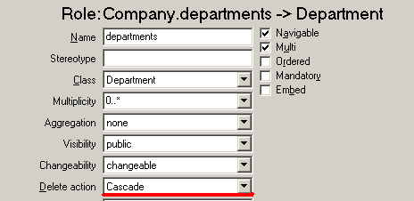
Figure 11: Business Unit, departments role
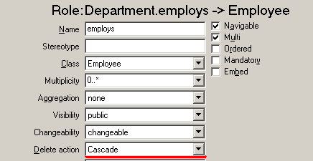
Figure 12: Employment, employs role
Now the model will automatically cleanup the designated objects.

Run the application and checkout the change. Previously when deleting a department, the employees would still remain (visible in the All Object grid). Now they are correctly cleaned up.

Derived & Reverse Derived Attributes
So far we have only use simple attributes within our application. Each attribute has been a basic type (string & currency) and saved/restored from the database. Similar to calculated fields in a traditional Delphi database application, in Bold for Delphi it is possible to calculate the value of an attribute ‘on the fly’. I say similar because Bold for Delphi extends the calculate field concept far beyond the capabilities of traditional Delphi database applications.

The most significant difference is the ability to make a derived attribute write-able. This is called reverse derived. The process of enabling this functionality is simple in a Bold for Delphi application.

Adding the new attributes
The new model will include a derived attribute on the Workplace class and a reverse-derived attribute on the Employee class. The Workplace class now includes the monthlyCost attribute, which is then inherited and overridden, in both the Company and Department classes. The Employee class now includes the attribute fullName which, when changed, can make the appropriate changes to the firstName and lastName attributes.

Figure 13 shows the updated UML model.
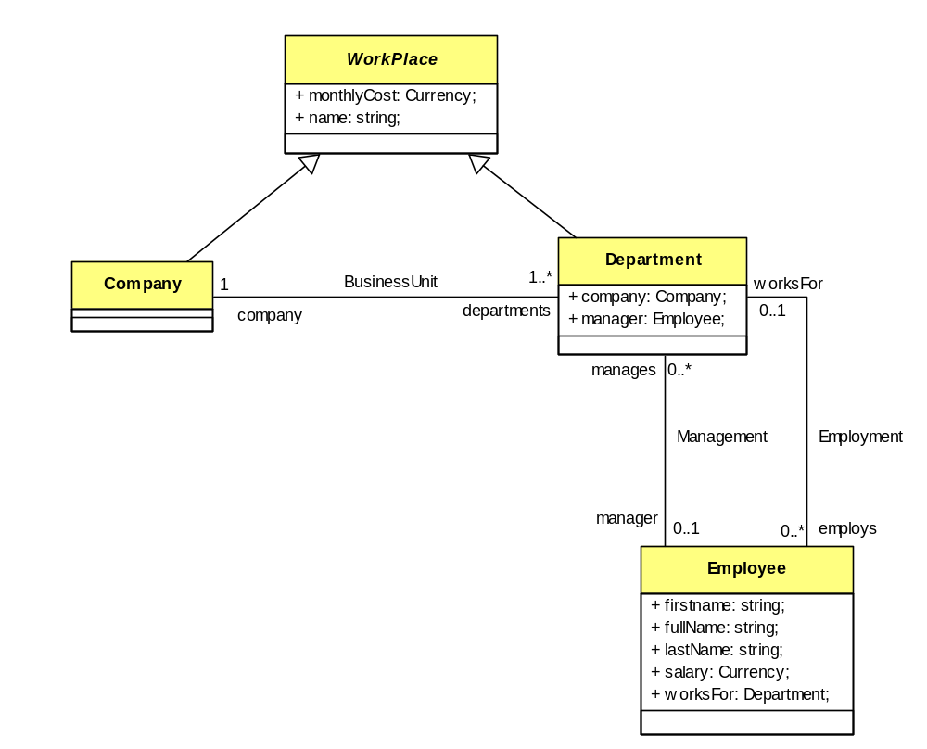
Figure 13: UML Model including new attributes
Figure 14 shows the new attributes in the Bold UML Model editor.

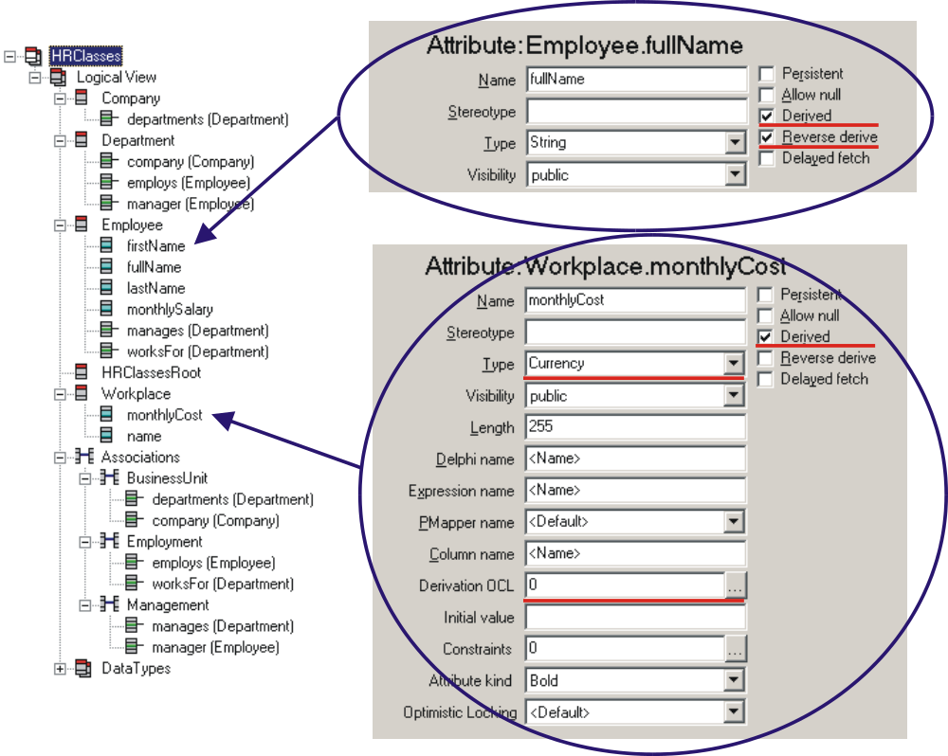
Figure 14: Adding the new attributes

After adding the new attributes it is important to use the Generate Code menu option from the Bold UML Editor to ensure the correct procedure stubs are generated. After generating the code a new HRClasses.inc file is created and loaded in the IDE editor.

The following method stubs are created for deriving and reverse deriving the employee’s fullname:

procedure TEmployee._fullName_DeriveAndSubscribe(DerivedObject: TObject; Subscriber: TBoldSubscriber);

procedure TEmployee._fullName_ReverseDerive(DerivedObject: TObject);

Methods are not created for the derived monthlyCost attribute because we supplied an OCL expression. The expression returns a default value of zero; this will be overridden in each descendant class later.

Reversed Derived
Add the following code for the employee’s fullName attribute:
procedure TEmployee._fullName_DeriveAndSubscribe(DerivedObject: TObject; Subscriber: TBoldSubscriber);
begin
// Set the fullname
M_FullName.AsString := firstName + ' ' + lastName;

// subscribe to notifications of either the first
// or last name changing
M_FirstName.DefaultSubscribe(subscriber);
M_LastName.DefaultSubscribe(subscriber);
end;

procedure TEmployee._fullName_ReverseDerive(DerivedObject: TObject);
var aFullName: String;
p: integer;
begin
// strip away leading and trailing spaces
aFullName := trim(fullName);
// Check if a space was found
p := pos( ' ', aFullName );
if p <> 0 then
begin
// the first name is everything up to the first space
// the last name is the rest
firstName := copy( aFullName, 1, p-1 );
lastName := trim(copy(aFullName, p+1, maxint ));
end else
begin
// No space found, the first name is everything,
// the last name is set blank
firstName := aFullName;
lastName := ‘’;
end;
end;

To understand what these methods are doing it is helpful to have a look at the declaration for the TEmployee class. The following has been stripped down to include on properties and methods important to the description of the above methods.

TEmployee = class(THRClassesRoot)
protected
procedure _fullName_DeriveAndSubscribe(DerivedObject: TObject;
Subscriber: TBoldSubscriber); virtual;
procedure _fullName_ReverseDerive(DerivedObject: TObject);
virtual;
public
property M_firstName: TBAString read _Get_M_firstName;
property M_lastName: TBAString read _Get_M_lastName;
property M_fullName: TBAString read _Get_M_fullName;
property firstName: String read _GetfirstName write
_SetfirstName;
property lastName: String read _GetlastName write _SetlastName;
property fullName: String read _GetfullName write _SetfullName;
end;

From this you can clearly see the methods we have just entered (in the protected section). However, it’s interesting to see that we seem to have a double up of properties for each attribute.

For each property Bold for Delphi creates, it also creates the same property with a M_ prefix. This second property returns a special Bold for Delphi object. This object is used to represent the base type of the property, as an object. The reasons Bold for Delphi creates these runtime information classes are many:
- Allow for subscriptions to allow notifications when the value changes.
- Cache old value so changes can be discarded without refreshing from the database.
- Allow for fine-grained control of persistence at the attribute level.
- To support optimistic locking.

If first we look at the method declaration:

procedure TEmployee._fullName_DeriveAndSubscribe(DerivedObject:
TObject; Subscriber: TBoldSubscriber);

Here we have two parameters, DerivedObject and Subscriber. The DerivedObject in this case is the internal TBAString object used to represent the fullName attribute. This is the same object return form the M_FullName property. In the code I have decided to directly access the M_FullName property as this is more readable. We could have typecast the DerivedObject object as a TBAString if we chose. The Subscriber is the internal subscription object for this property, it is our responsibility to use this object to subscribe to any other object attributes that we need to know have changed. This subscription allows for the fullName property to respond to the change of firstName or lastName and correctly show the updated value.

Setting the property value:
M_FullName.AsString := firstName + ' ' + lastName;

The employee’s full name is simply the first name and last name separated with a space.

M_FirstName.DefaultSubscribe(subscriber);
M_LastName.DefaultSubscribe(subscriber);

Here the subscriber for the fullName attribute attaches itself to the subscription mechanism for each of the other name attributes.

If you run the application and use the default object form, you can see the read/write behavior of the new fullName attribute in action.

Derived Attributes with OCL
In the decendant class of Workplace we can override the OCL for the monthlyCost attribute. This allows for the full used of polymorphism by changing the behavior of the attribute for each descendant class.

To override OCL derived attributes in Bold for Delphi place an entry in the Derived Expressions property of the class. This is shown in Figure 15.

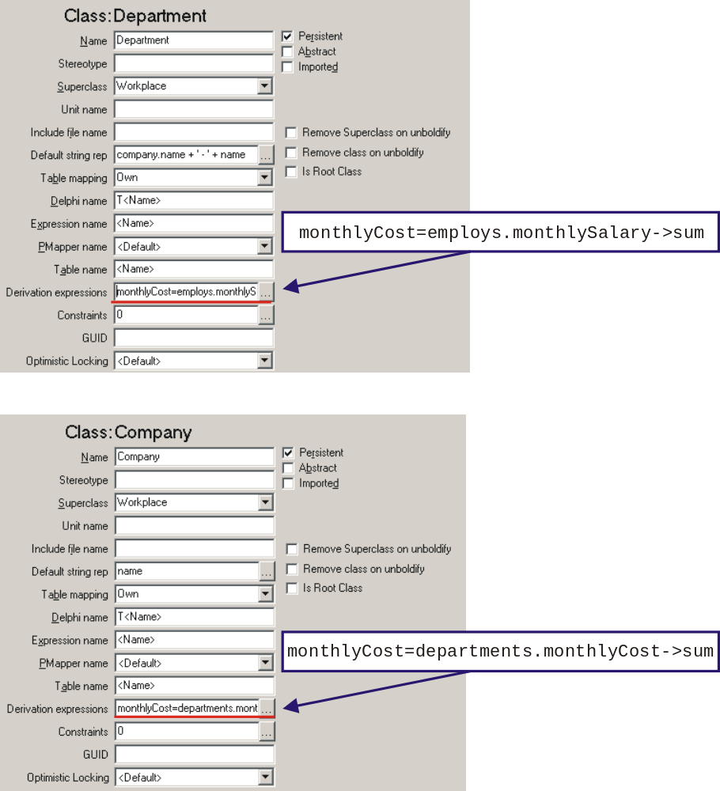
Figure 15: Overriding derived OCL expressions
The Derivation Expressions property of the class contains a string list of all the overridden derived OCL expressions. The format of each line is:

<inherited attribute name>=<new OCL expression>

In the example above the Department class now calculates the monthlyCost value as being the sum of all employee’s salaries for that department. The Company class calculates the monthlyCost value as being the sum of all monthly costs for each department.

For both the Company and the Department grid we can add a new column and set the OCL expression to monthlyCost. At runtime the screen will look similar to Figure 16.

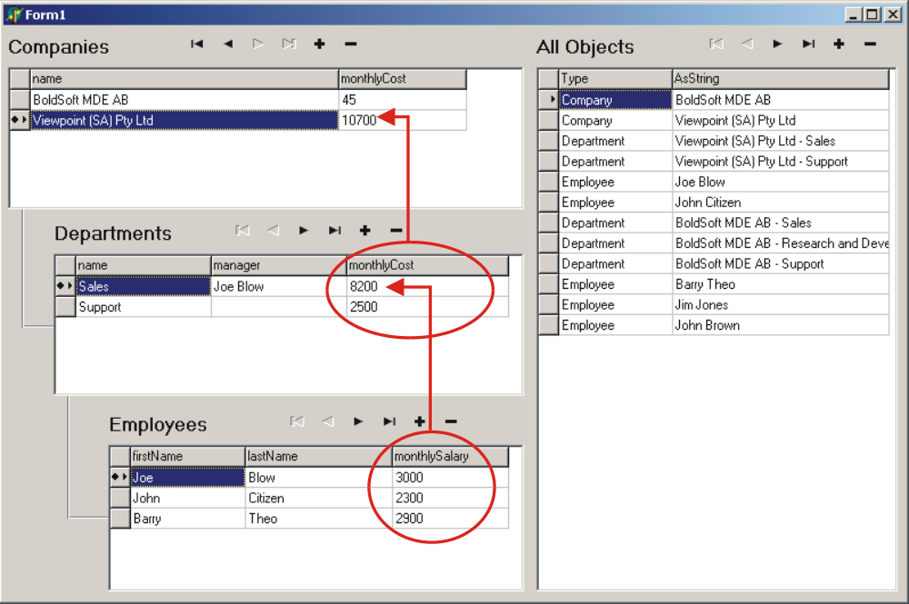
Figure 16: Derived Attributes at Runtime

Operations
So far we have discussed attributes and relationships, another very important part of Bold for Delphi is Operations. Operations allow you to add behavior to your classes and are vital to allowing you to implement all the required business rules for an application.

Operations are implemented using standard Delphi Object Pascal. They are the equivalent to methods in standard Delphi classes. Operations are used to implement tasks within your classes, like LightBulb.change.

Adding an Operation
Add the adjustSalary operation shown in the updated UML model in Figure 17.
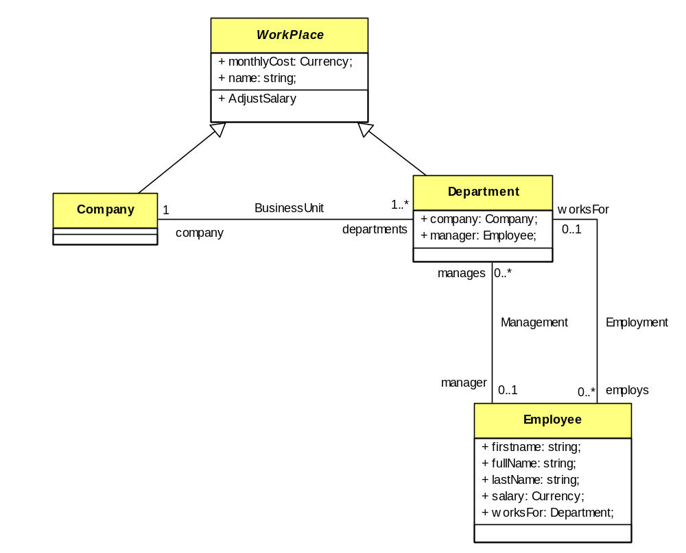
Figure 17: Adding an Operation
The adjustSalary operation doesn’t need to do anything in the base Workplace class. In both the Company and Department classes it will be overridden to supply different behavior for each class.

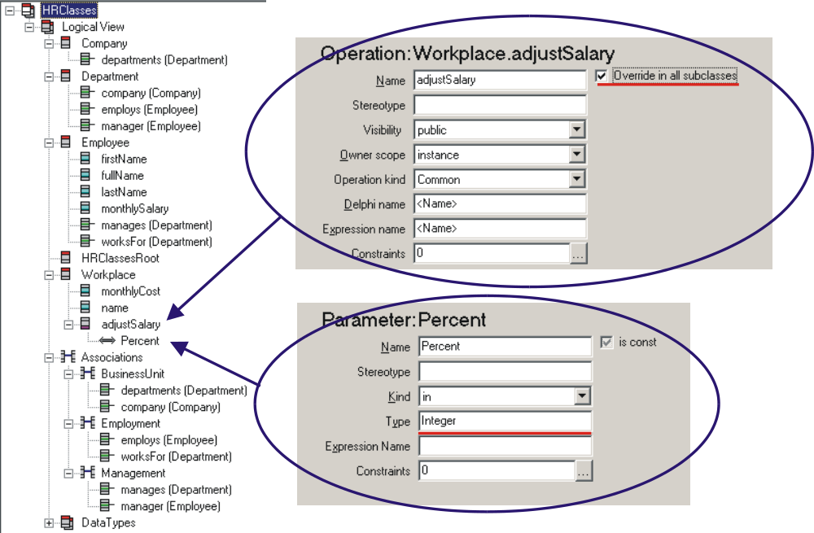
Figure 18: Adding the adjustSalary Operation
After adding the operation you will need to use Generate Code from the Tools menu. The following method stubs are added to HRClasses.inc.

procedure TWorkplace.adjustSalary(Percent: Integer);
begin
end;

procedure TCompany.adjustSalary(Percent: Integer);
begin
inherited;
end;

procedure TDepartment.adjustSalary(Percent: Integer);
begin
inherited;
end;

No behavior is required in the Workplace class so we will only add code to the Company and Department implementations.

procedure TCompany.adjustSalary(Percent: Integer);
var counter: Integer;
begin
inherited;
// Loop thru all departments and call
// adjustSalary for each one
for Counter := 0 to departments.Count -1 do
departments[counter].adjustSalary(Percent);
end;

procedure TDepartment.adjustSalary(Percent: Integer);
var counter: Integer;
SalaryChange: Currency;
begin
inherited;
// Loop thru all employee's and adjust their
// salary
for Counter := 0 to employs.Count -1 do
begin
SalaryChange := employs[counter].monthlySalary * (Percent / 100);
employs[counter].monthlySalary := employs[counter].monthlySalary
+ SalaryChange;
end;
end;

To show the effect of this new operation we will add a pop-up menu to both grids and allow the user to adjust salaries.

Add a new TpopupMenu to the form and call it SalaryPopupMenu.
Set both the CompanyGrid and the DepartmentGrid to use this new poupmenu by setting the PopupMenu parameter of each grid.

Add a private field to the form’s class declaration:

type
TForm1 = class(TForm)
…
private
{ Private declarations }
FCurrentWorkplace: TWorkplace;
public
{ Public declarations }
end;

Add the following code to the OnContextPopup event of the DepartmentGrid:

procedure TForm1.DepartmentGridContextPopup(Sender: TObject;
MousePos: TPoint; var Handled: Boolean);
begin
// Initialize menu item and form private field
AdjustSalary1.Enabled := False;
FCurrentWorkplace := nil;

// Check that the object is a Workplace object and
// assigned it to our local variable
if DepartmentGrid.CurrentBoldElement is TWorkplace then
begin
AdjustSalary1.Enabled := True;
FCurrentWorkplace :=
TWorkplace(DepartmentGrid.CurrentBoldElement);
end;
end;

Add the following code to the OnContextPopup event of the CompanyGrid:

procedure TForm1.CompanyGridContextPopup(Sender: TObject; MousePos: TPoint; var Handled: Boolean);
begin
// Initialize menu item and form private field
AdjustSalary1.Enabled := False;
FCurrentWorkplace := nil;
// Check that the object is a Workplace object and
// assigned it to our local variable
if CompanyGrid.CurrentBoldElement is TWorkplace then
begin
AdjustSalary1.Enabled := True;
FCurrentWorkplace :=
TWorkplace(CompanyGrid.CurrentBoldElement);
end;
end;

Both of these events are very similar. They check that a valid Workplace is selected in the grid and assign it to the local form’s private field FcurrentWorkplace. The popup menu can then use this.

Add a menu item to the popup menu with the caption ‘Adjust Salary’. In the menu items OnClick event add the following code:

procedure TForm1.AdjustSalary1Click(Sender: TObject);
var PercentStr: String;
PercentInt: Integer;
begin
// Ensure that the local form field is assigned
// an object
if assigned(FCurrentWorkplace) then
begin
// Display a pop-up requesting the percent to
// adjust the salaries by
PercentStr := '10';
if InputQuery('Salary Adjustment', 'Enter adjustment percentage',
PercentStr) then
begin
try
// call the adjustSalaries method of with the supplied percent
PercentInt := StrToInt(PercentStr);
FCurrentWorkplace.adjustSalary(PercentInt);
except
on EConvertError do
MessageDlg('Invalid Percent entered!', mtError, [mbOK], 0);
end;
end;
end;
end;

The above code works for both grids because we use the base class of the objects making the code type compatible. This is an enormous benefit in reducing redundant code and helps ensure code re-use. The method simply prompts for an adjustment percentage and calls the adjustSalary method of the object. If the object is a Company then the adjustSalary method of that class is used, if the object is a Department then that version of the method is used. Fortunately that fact doesn’t need to be known by the popup code above, Object Pascal and Bold for Delphi takes care of this for us.

Derived Relationships
With the power of derived, reverse derived attributes and operations it is easy to see how extending a Bold for Delphi application to truly integrate business rules into the model is easy. Bold for Delphi can extend this even further by deriving relationships ‘on the fly’. The advantage of this is, as previously discussed, is reduced complexity, centralized business rules, ease of maintenance. This also reduces redundancy of data, sometime when implementing a database the rules of normalization are broken to accommodate reports or programming requirements. Data that can be easily derived from existing information is instead duplicated in one or more tables. This can result in problems as the application evolves or problems during normal operation ensuring the data is kept synchronized.

By using derived relationships, the benefit of having the information readily available and without redundant data can help ease the application development and maintenance. Figure 19 shows two new relationships in our model, Workforce and Managed By.
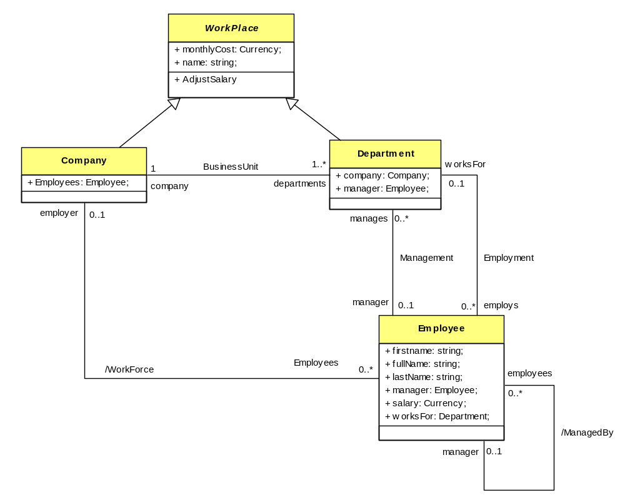
Figure 19: Derived Relationships
The Managed By relationship represents the manager for that employee; this is simply whoever is managing the department the employee works for. The Workforce relationship represents the employer of the employee; this is the company that owns the department that the employee works for.

Adding the Managed By relationship
Add the Managed By relationship as per Figure 20:

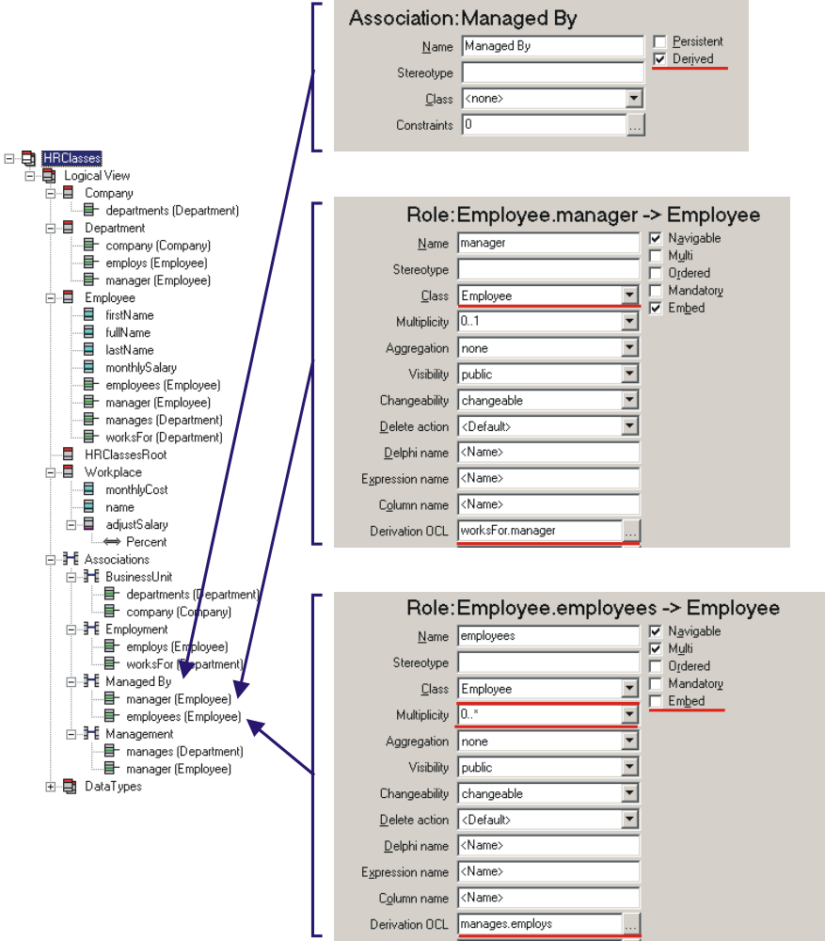
Figure 20: Derived Relationship – Managed By
The OCL expression worksFor.manager will return the employee who manages the department the current employee works for. The OCL expression manages.employs will return a list of employees. This list is the combination of all employees that work for all the departments that the current employee manages.

This behavior can be observed at runtime using the Bold for Delphi default object forms. Open an employee and drag a few departments into the manages tab. The employees’ tab now lists all employees for the departments managed by that employee.

Adding the Workforce relationship
Add the Workforce relationship as per Figure 21:

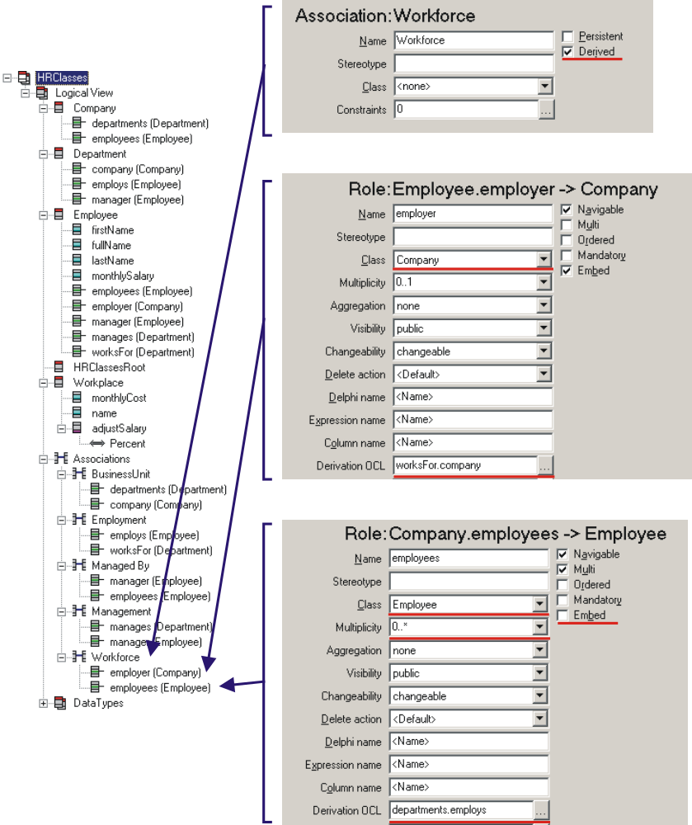
Figure 21: Derived Relationship – Workforce
The behavior can easily be shown by using the default Bold for Delphi object forms at runtime. The new employee tab for the Company class shows all employees for all departments. The Employer field for the Employee class now shows the employer.

One-way Relationships
We will now take a look at a one-way relationship, although not too different from what we have already done, it will give us an opportunity to explore some more of the options available with relationships.

In the UML model in Figure 22 the relationship Top Salaries has been added. This provided an association from Workplace to Employee identifying highlyPaidEmployees. To help facilitate the use of this new relationship the attribute highSalaryThreshold has been added to the Department class.

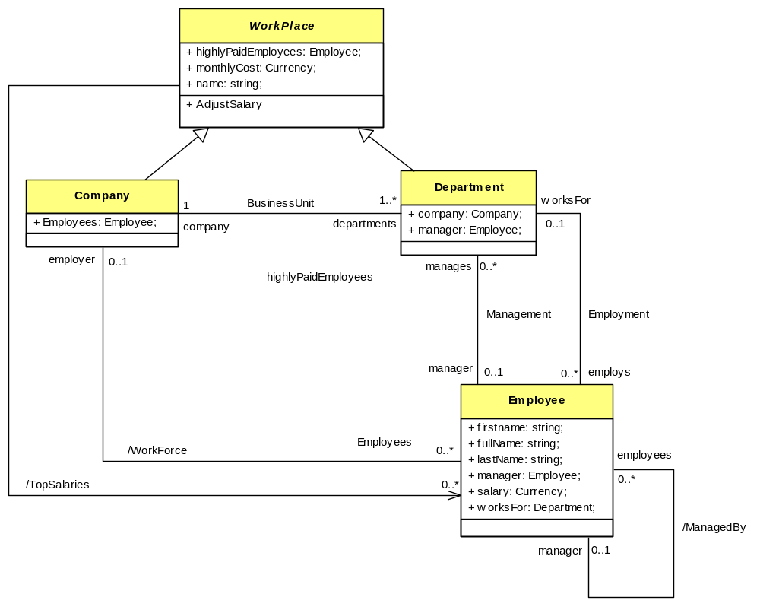
Figure 22: One-way Relationship

This is implemented in the Bold UML Model Editor as follows:

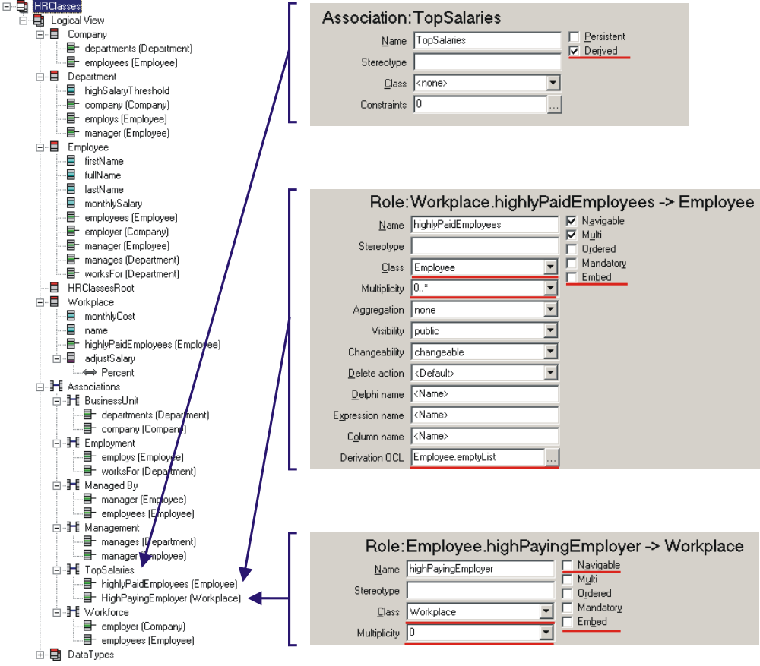
Figure 23: Implementing Top Salaries
The interesting items when implementing this association are:
- The role highlyPaidEmployees uses the OCL expression Employee.emptyList. This expression results in an empty list of type Employee objects. The reason we use this expression is because the Class of the association is Employee. Even though Workplace is an abstract class, all descendant classes will inherit this association It is important that it returns a valid result if called. If the OCL expression were blank Bold for Delphi would create a method stub to allow you to create your own result in code. Because we will be overriding the result using OCL in descendants the expression above was required.
- The role highPayingEmployer is not required in a business sense, indeed deriving a result really adds no value to the model at all. Having the role here is important because assigning the Class property to Workplace gives us the context for the other role. The trick to removing this otherwise useless role from appearing in the Employee class and generated code is to mark it as not Navigable. This was done by un-checking the Navigable checkbox.

At the moment the association offers no value, as it will always return an empty list. By overriding the OCL expression in descendant classes we can generate a list of Employees.

Add the following attribute to the Department class:

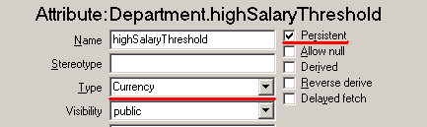
Figure 24: Attribute – highSalaryThreshold

This attribute will be used to determine which employees in a department are considered as having a high salary. This means we need to now override the implementation of highlyPaidEmployees in both the Company and Department classes.

This is done by adding another entry to the Derivation Expression property of the two classes.
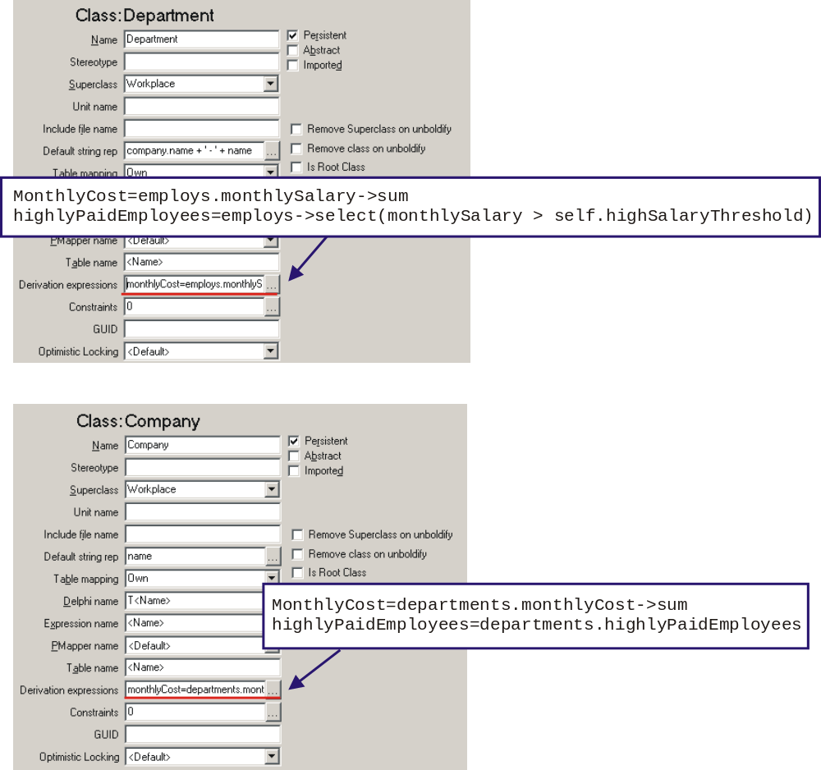
Figure 25: Derivation Expressions
The OCL expression used for the Department class uses the highSalaryThreshold attribute to determine which employees are considered as being highly paid. The Company class simply aggregates all the highly paid employees of it departments to provide a consolidated list.

The behavior can be investigated using the Bold for Delphi default object forms at runtime, however let’s add a few more controls to give us a result on our main form. Figure 26 shows the enhanced main form at design time.

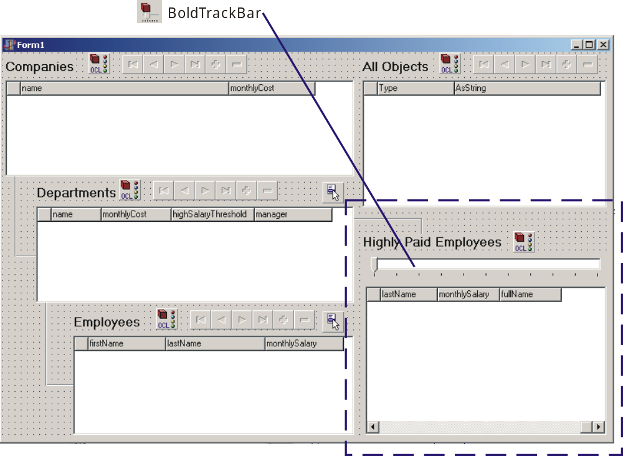
Figure 26: Enhancing the GUI
From the Bold Handles component palette add a BoldListHandle component to the form. From the Bold Controls component palette add a BoldTackBar and a BoldGrid components. Also add a standard Delphi Label and a couple Bevel components to help keep everything in order.

BoldListHandle
Name: HighlyPaidEmployeesList
RootHandle: DepartmentList
Expression: highlyPaidEmployees
Enabled: True

BoldTrackBar
Name: SalaryThresholdTrackBar
BoldHandle: DepartmentList
BoldProperties.Expression: highSalaryThreshold
BoldProperties.ApplyPolicy: bapChange
Min: 0
Max: 5000
Frequency: 500
Enabled: True

BoldGrid
Name: HighlyPaidEmployeesGrid
BoldHandle: HighlyPaidEmployeesList

After setting the BoldHandle property, right-click on the grid and select Create Default Columns from the context menu.

Run the application. Choose a department and add several employees with a spread of monthly salaries between 0 and 5000. Now slide the trackbar, Bold for Delphi dynamically responds with the correct result in the grid.

If you open the default editor for the Company and select the highlyPaidEmployees tab, you will see the highly paid employees for all departments. The beauty of Bold for Delphi is this list also dynamically updates as you move the slider. The synchronization methods of Bold for Delphi are extremely powerful and make creating loosely coupled forms easy.

Constraints: A parting note
An important aspect of Bold for Delphi is constraints. These are used to validate objects. Constraints can be specifically entered or implicit based on a relationship role. For example the role Company as part of the BusinessUnit association has a multiplicity of 1 specified. This means that every department must have a relationship with a company. However, as you can quickly check by running the application (prior to adding the cascade delete) that it is certainly possible to do so.

It would be to limiting or impractical for Bold for Delphi to try and enforce this constraint automatically as almost certainly the resulting behavior won’t suit your particular scenario. Bold for Delphi however provides the ability to test the constraints, even as part of the delete verification process for your objects.

This is mentioned only because you may have been aware that certain aspects of the model were not being enforced in this way. However the Bold for Delphi constraint mechanism is powerful and fully assessable at runtime via code and Bold-aware components.

The subject of constraints will be addressed in a future article.

Summary
A lot of information has been presented in this article. The power of moving information about the application from the GUI and source into the model allows for a more precise definition of business rules. The centralized containment of business rule is a good way to ensure they are implemented in the application.
Designing an application with the knowledge everything modeled can actually be implemented, without worrying about technical details such as DB schema, linked lists, updating queries and moving data from the GUI into the logic layer allows focus to stay on the domain problem at hand. Keeping focus on the domain problems, rather than implementation problems ensures energy is spent on the right issues.

Bold for Delphi offers the most powerful assurance ever produced that your application is actually based on the model, and that the model will always accurately reflect the true implementation.

Appendix A: Source Code

Instructions
In this section you will find the source code for the project used in this article. All files can be created using an standard ASCII text editor like notepad.exe. Cut and paste the contents of each file and save the file using the correct name and extension.

The format of the listing is:

Start listing Filename
Contents of file
In between the lines.
End listing Filename

All files need to placed in the same directory, then simply load the DPR file into Delphi and compile.

HRManager.dpr
Start listing HRManager.dpr
program HRManager;

uses
Forms,
MainForm in 'MainForm.pas' {Form1},
BusinessLayer in 'BusinessLayer.pas' {BusinessModule: TDataModule},
HRClasses in 'HRClasses.pas';

{$R *.RES}

begin
Application.Initialize;
Application.CreateForm(TForm1, Form1);
Application.CreateForm(TBusinessModule, BusinessModule);
Application.Run;
end.
End Listing HRManager.dpr

MainForm.pas
Start listing MainForm.pas
unit MainForm;

interface

uses
Windows, Messages, SysUtils, Classes, Graphics, Controls, Forms, Dialogs,
BoldSubscription, BoldHandles, BoldRootedHandles, BoldAbstractListHandle,
BoldCursorHandle, BoldListHandle, ExtCtrls, BoldNavigator, Grids,
BoldGrid, StdCtrls, BoldAFPDefault, BusinessLayer, Menus, BoldEdit,
HRClasses, ComCtrls, BoldTrackBar, BoldNavigatorDefs;

type
TForm1 = class(TForm)
Label1: TLabel;
Label2: TLabel;
Label3: TLabel;
CompanyGrid: TBoldGrid;
CompanyNavigator: TBoldNavigator;
DepartmentGrid: TBoldGrid;
EmployeeGrid: TBoldGrid;
DepartmentNavigator: TBoldNavigator;
EmployeeNavigator: TBoldNavigator;
CompanyList: TBoldListHandle;
DepartmentList: TBoldListHandle;
EmployeeList: TBoldListHandle;
Bevel1: TBevel;
Bevel2: TBevel;
Bevel3: TBevel;
Bevel4: TBevel;
Label4: TLabel;
ObjectList: TBoldListHandle;
ObjectNavigator: TBoldNavigator;
ObjectGrid: TBoldGrid;
EmployeePopupMenu: TPopupMenu;
AddNewEmployee1: TMenuItem;
DeleteEmployee1: TMenuItem;
MakeManager1: TMenuItem;
SalaryPopupMenu: TPopupMenu;
AdjustSalary1: TMenuItem;
HighlyPaidEmployeesGrid: TBoldGrid;
HighlyPaidEmployeesList: TBoldListHandle;
SalaryThresholdTrackBar: TBoldTrackBar;
Label5: TLabel;
Bevel5: TBevel;
Bevel6: TBevel;
procedure EmployeeGridContextPopup(Sender: TObject; MousePos: TPoint;
var Handled: Boolean);
procedure MakeManager1Click(Sender: TObject);
procedure AddNewEmployee1Click(Sender: TObject);
procedure DeleteEmployee1Click(Sender: TObject);
procedure AdjustSalary1Click(Sender: TObject);
procedure DepartmentGridContextPopup(Sender: TObject; MousePos: TPoint;
var Handled: Boolean);
procedure CompanyGridContextPopup(Sender: TObject; MousePos: TPoint;
var Handled: Boolean);
private
{ Private declarations }
FCurrentWorkplace: TWorkplace;
public
{ Public declarations }
end;

var
Form1: TForm1;

implementation
{$R *.DFM}

procedure TForm1.EmployeeGridContextPopup(Sender: TObject;
MousePos: TPoint; var Handled: Boolean);
var
EmployeeAssigned: Boolean;
begin
// Enable/Disable Menu items depending if an Employee is
// selected.
EmployeeAssigned := EmployeeGrid.CurrentBoldElement is TEmployee;
MakeManager1.Enabled := EmployeeAssigned;
DeleteEmployee1.Enabled := EmployeeAssigned;

// Enable/Disable Menu items depending if a department is selected.
AddNewEmployee1.Enabled := DepartmentGrid.CurrentBoldElement is TDepartment;
end;

procedure TForm1.MakeManager1Click(Sender: TObject);
var CurrentEmployee: TEmployee;
begin
// Check that the object is an Employee object and
// assigned it to our local variable
if EmployeeGrid.CurrentBoldElement is TEmployee then
begin
CurrentEmployee := TEmployee(EmployeeGrid.CurrentBoldElement);

// Check if the employee works for a department and set the
// employee as the manager
if assigned(CurrentEmployee.worksFor) then
CurrentEmployee.worksFor.manager := CurrentEmployee;
end;
end;

procedure TForm1.AddNewEmployee1Click(Sender: TObject);
var NewEmployee: TEmployee;
CurrentDepartment: TDepartment;
begin
// Because the Context Pop-up code has already checked
// that the current element is a TDepartment we can
// typecast to TDepartment safely
CurrentDepartment := TDepartment(DepartmentGrid.CurrentBoldElement);

// Create a new Employee object
NewEmployee := TEmployee.Create(CurrentDepartment.BoldSystem);
// Set the department of the new employee to the current
// department
NewEmployee.worksFor := CurrentDepartment;
end;

procedure TForm1.DeleteEmployee1Click(Sender: TObject);
var CurrentEmployee: TEmployee;
begin
// Check that the object is an Employee object and
// Delete it
if EmployeeGrid.CurrentBoldElement is TEmployee then
TEmployee(EmployeeGrid.CurrentBoldElement).Delete;
end;

procedure TForm1.AdjustSalary1Click(Sender: TObject);
var PercentStr: String;
PercentInt: Integer;
begin
// Ensure that the local form field is assigned
// an object
if assigned(FCurrentWorkplace) then
begin
// Display a pop-up requesting the percent to
// adjust the salaries by
PercentStr := '10';
if InputQuery('Salary Adjustment','Enter adjustment percentage', PercentStr) then
begin
try
// call the adjustSalaries method of
// with the supplied percent
PercentInt := StrToInt(PercentStr);
FCurrentWorkplace.adjustSalary(PercentInt);
except
on EConvertError do
MessageDlg('Invalid Percent entered!', mtError, [mbOK], 0);
end;
end;
end;
end;

procedure TForm1.DepartmentGridContextPopup(Sender: TObject;
MousePos: TPoint; var Handled: Boolean);
begin
// Initialize menu item and form private field
AdjustSalary1.Enabled := False;
FCurrentWorkplace := nil;

// Check that the object is a Workplace object and
// assigned it to our local variable
if DepartmentGrid.CurrentBoldElement is TWorkplace then
begin
AdjustSalary1.Enabled := True;
FCurrentWorkplace := TWorkplace(DepartmentGrid.CurrentBoldElement);
end;
end;

procedure TForm1.CompanyGridContextPopup(Sender: TObject; MousePos: TPoint;
var Handled: Boolean);
begin
// Initialize menu item and form private field
AdjustSalary1.Enabled := False;
FCurrentWorkplace := nil;

// Check that the object is a Workplace object and
// assigned it to our local variable
if CompanyGrid.CurrentBoldElement is TWorkplace then
begin
AdjustSalary1.Enabled := True;
FCurrentWorkplace := TWorkplace(CompanyGrid.CurrentBoldElement);
end;
end;

end.
End Listing MainForm.pas

MainForm.dfm
Start listing MainForm.dfm
object Form1: TForm1
Left = 421
Top = 203
Width = 799
Height = 531
Caption = 'Form1'
Color = clBtnFace
Font.Charset = DEFAULT_CHARSET
Font.Color = clWindowText
Font.Height = -11
Font.Name = 'MS Sans Serif'
Font.Style = []
OldCreateOrder = False
PixelsPerInch = 96
TextHeight = 13
object Bevel3: TBevel
Left = 56
Top = 424
Width = 41
Height = 9
Shape = bsBottomLine
end
object Bevel2: TBevel
Left = 56
Top = 320
Width = 9
Height = 113
Shape = bsLeftLine
end
object Bevel4: TBevel
Left = 16
Top = 256
Width = 41
Height = 9
Shape = bsBottomLine
end
object Bevel1: TBevel
Left = 16
Top = 160
Width = 9
Height = 105
Shape = bsLeftLine
end
object Label1: TLabel
Left = 4
Top = 8
Width = 90
Height = 20
Caption = 'Companies'
Font.Charset = DEFAULT_CHARSET
Font.Color = clWindowText
Font.Height = -16
Font.Name = 'MS Sans Serif'
Font.Style = [fsBold]
ParentFont = False
end
object Label2: TLabel
Left = 44
Top = 172
Width = 105
Height = 20
Caption = 'Departments'
Font.Charset = DEFAULT_CHARSET
Font.Color = clWindowText
Font.Height = -16
Font.Name = 'MS Sans Serif'
Font.Style = [fsBold]
ParentFont = False
end
object Label3: TLabel
Left = 92
Top = 340
Width = 88
Height = 20
Caption = 'Employees'
Font.Charset = DEFAULT_CHARSET
Font.Color = clWindowText
Font.Height = -16
Font.Name = 'MS Sans Serif'
Font.Style = [fsBold]
ParentFont = False
end
object Label4: TLabel
Left = 468
Top = 8
Width = 87
Height = 20
Caption = 'All Objects'
Font.Charset = DEFAULT_CHARSET
Font.Color = clWindowText
Font.Height = -16
Font.Name = 'MS Sans Serif'
Font.Style = [fsBold]
ParentFont = False
end
object Bevel5: TBevel
Left = 456
Top = 208
Width = 89
Height = 9
Shape = bsBottomLine
end
object Bevel6: TBevel
Left = 544
Top = 216
Width = 9
Height = 25
Shape = bsLeftLine
end
object Label5: TLabel
Left = 468
Top = 236
Width = 182
Height = 20
Caption = 'Highly Paid Employees'
Font.Charset = DEFAULT_CHARSET
Font.Color = clWindowText
Font.Height = -16
Font.Name = 'MS Sans Serif'
Font.Style = [fsBold]
ParentFont = False
end
object CompanyGrid: TBoldGrid
Left = 4
Top = 36
Width = 453
Height = 125
AddNewAtEnd = False
BoldAutoColumns = False
BoldShowConstraints = False
BoldHandle = CompanyList
BoldProperties.NilElementMode = neNone
Columns = <
item
Color = clBtnFace
Font.Charset = DEFAULT_CHARSET
Font.Color = clWindowText
Font.Height = -11
Font.Name = 'MS Sans Serif'
Font.Style = []
end
item
BoldProperties.Expression = 'name'
Font.Charset = DEFAULT_CHARSET
Font.Color = clWindowText
Font.Height = -11
Font.Name = 'MS Sans Serif'
Font.Style = []
end
item
BoldProperties.Expression = 'monthlyCost'
Font.Charset = DEFAULT_CHARSET
Font.Color = clWindowText
Font.Height = -11
Font.Name = 'MS Sans Serif'
Font.Style = []
end>
DefaultRowHeight = 17
EnableColAdjust = False
PopupMenu = SalaryPopupMenu
TabOrder = 0
TitleFont.Charset = DEFAULT_CHARSET
TitleFont.Color = clWindowText
TitleFont.Height = -11
TitleFont.Name = 'MS Sans Serif'
TitleFont.Style = []
OnContextPopup = CompanyGridContextPopup
ColWidths = (
17
270
111)
end
object CompanyNavigator: TBoldNavigator
Left = 156
Top = 3
Width = 162
Height = 25
BoldHandle = CompanyList
Flat = True
TabOrder = 1
ImageIndices.nbFirst = -1
ImageIndices.nbPrior = -1
ImageIndices.nbNext = -1
ImageIndices.nbLast = -1
ImageIndices.nbInsert = -1
ImageIndices.nbDelete = -1
ImageIndices.nbMoveUp = -1
ImageIndices.nbMoveDown = -1
DeleteQuestion = 'Delete "%1:s"?'
UnlinkQuestion = 'Unlink "%1:s" from "%2:s"?'
RemoveQuestion = 'Remove "%1:s" from the list?'
end
object DepartmentGrid: TBoldGrid
Left = 44
Top = 200
Width = 413
Height = 125
AddNewAtEnd = False
BoldAutoColumns = False
BoldShowConstraints = False
BoldHandle = DepartmentList
BoldProperties.NilElementMode = neNone
Columns = <
item
Color = clBtnFace
Font.Charset = DEFAULT_CHARSET
Font.Color = clWindowText
Font.Height = -11
Font.Name = 'MS Sans Serif'
Font.Style = []
end
item
BoldProperties.Expression = 'name'
Font.Charset = DEFAULT_CHARSET
Font.Color = clWindowText
Font.Height = -11
Font.Name = 'MS Sans Serif'
Font.Style = []
end
item
BoldProperties.Expression = 'monthlyCost'
Font.Charset = DEFAULT_CHARSET
Font.Color = clWindowText
Font.Height = -11
Font.Name = 'MS Sans Serif'
Font.Style = []
end
item
BoldProperties.Expression = 'highSalaryThreshold'
Font.Charset = DEFAULT_CHARSET
Font.Color = clWindowText
Font.Height = -11
Font.Name = 'MS Sans Serif'
Font.Style = []
end
item
BoldProperties.Expression = 'manager'
Font.Charset = DEFAULT_CHARSET
Font.Color = clWindowText
Font.Height = -11
Font.Name = 'MS Sans Serif'
Font.Style = []
end>
DefaultRowHeight = 17
EnableColAdjust = False
PopupMenu = SalaryPopupMenu
TabOrder = 2
TitleFont.Charset = DEFAULT_CHARSET
TitleFont.Color = clWindowText
TitleFont.Height = -11
TitleFont.Name = 'MS Sans Serif'
TitleFont.Style = []
OnContextPopup = DepartmentGridContextPopup
ColWidths = (
17
64
90
107
100)
end
object EmployeeGrid: TBoldGrid
Left = 92
Top = 368
Width = 365
Height = 129
AddNewAtEnd = False
BoldAutoColumns = False
BoldShowConstraints = False
BoldHandle = EmployeeList
BoldProperties.NilElementMode = neNone
Columns = <
item
Color = clBtnFace
Font.Charset = DEFAULT_CHARSET
Font.Color = clWindowText
Font.Height = -11
Font.Name = 'MS Sans Serif'
Font.Style = []
end
item
BoldProperties.Expression = 'firstName'
Font.Charset = DEFAULT_CHARSET
Font.Color = clWindowText
Font.Height = -11
Font.Name = 'MS Sans Serif'
Font.Style = []
end
item
BoldProperties.Expression = 'lastName'
Font.Charset = DEFAULT_CHARSET
Font.Color = clWindowText
Font.Height = -11
Font.Name = 'MS Sans Serif'
Font.Style = []
end
item
BoldProperties.Expression = 'monthlySalary'
Font.Charset = DEFAULT_CHARSET
Font.Color = clWindowText
Font.Height = -11
Font.Name = 'MS Sans Serif'
Font.Style = []
end>
DefaultRowHeight = 17
EnableColAdjust = False
PopupMenu = EmployeePopupMenu
TabOrder = 3
TitleFont.Charset = DEFAULT_CHARSET
TitleFont.Color = clWindowText
TitleFont.Height = -11
TitleFont.Name = 'MS Sans Serif'
TitleFont.Style = []
OnContextPopup = EmployeeGridContextPopup
ColWidths = (
17
100
128
101)
end
object DepartmentNavigator: TBoldNavigator
Left = 196
Top = 167
Width = 162
Height = 25
BoldHandle = DepartmentList
Flat = True
TabOrder = 4
ImageIndices.nbFirst = -1
ImageIndices.nbPrior = -1
ImageIndices.nbNext = -1
ImageIndices.nbLast = -1
ImageIndices.nbInsert = -1
ImageIndices.nbDelete = -1
ImageIndices.nbMoveUp = -1
ImageIndices.nbMoveDown = -1
DeleteQuestion = 'Delete "%1:s"?'
UnlinkQuestion = 'Unlink "%1:s" from "%2:s"?'
RemoveQuestion = 'Remove "%1:s" from the list?'
end
object EmployeeNavigator: TBoldNavigator
Left = 244
Top = 335
Width = 162
Height = 25
BoldHandle = EmployeeList
Flat = True
TabOrder = 5
ImageIndices.nbFirst = -1
ImageIndices.nbPrior = -1
ImageIndices.nbNext = -1
ImageIndices.nbLast = -1
ImageIndices.nbInsert = -1
ImageIndices.nbDelete = -1
ImageIndices.nbMoveUp = -1
ImageIndices.nbMoveDown = -1
DeleteQuestion = 'Delete "%1:s"?'
UnlinkQuestion = 'Unlink "%1:s" from "%2:s"?'
RemoveQuestion = 'Remove "%1:s" from the list?'
end
object ObjectNavigator: TBoldNavigator
Left = 612
Top = 3
Width = 162
Height = 25
BoldHandle = ObjectList
Flat = True
TabOrder = 6
ImageIndices.nbFirst = -1
ImageIndices.nbPrior = -1
ImageIndices.nbNext = -1
ImageIndices.nbLast = -1
ImageIndices.nbInsert = -1
ImageIndices.nbDelete = -1
ImageIndices.nbMoveUp = -1
ImageIndices.nbMoveDown = -1
DeleteQuestion = 'Delete "%1:s"?'
UnlinkQuestion = 'Unlink "%1:s" from "%2:s"?'
RemoveQuestion = 'Remove "%1:s" from the list?'
end
object ObjectGrid: TBoldGrid
Left = 468
Top = 36
Width = 317
Height = 165
AddNewAtEnd = False
BoldAutoColumns = False
BoldShowConstraints = False
BoldHandle = ObjectList
BoldProperties.NilElementMode = neNone
Columns = <
item
Color = clBtnFace
Font.Charset = DEFAULT_CHARSET
Font.Color = clWindowText
Font.Height = -11
Font.Name = 'MS Sans Serif'
Font.Style = []
end
item
BoldProperties.Expression = 'self.oclType'
Font.Charset = DEFAULT_CHARSET
Font.Color = clWindowText
Font.Height = -11
Font.Name = 'MS Sans Serif'
Font.Style = []
Title.Caption = 'Type'
end
item
Font.Charset = DEFAULT_CHARSET
Font.Color = clWindowText
Font.Height = -11
Font.Name = 'MS Sans Serif'
Font.Style = []
Title.Caption = 'AsString'
end>
DefaultRowHeight = 17
EnableColAdjust = False
TabOrder = 7
TitleFont.Charset = DEFAULT_CHARSET
TitleFont.Color = clWindowText
TitleFont.Height = -11
TitleFont.Name = 'MS Sans Serif'
TitleFont.Style = []
ColWidths = (
17
99
189)
end
object HighlyPaidEmployeesGrid: TBoldGrid
Left = 472
Top = 304
Width = 313
Height = 193
AddNewAtEnd = False
BoldAutoColumns = False
BoldShowConstraints = False
BoldHandle = HighlyPaidEmployeesList
BoldProperties.NilElementMode = neNone
Columns = <
item
Color = clBtnFace
Font.Charset = DEFAULT_CHARSET
Font.Color = clWindowText
Font.Height = -11
Font.Name = 'MS Sans Serif'
Font.Style = []
end
item
BoldProperties.Expression = 'firstName'
Font.Charset = DEFAULT_CHARSET
Font.Color = clWindowText
Font.Height = -11
Font.Name = 'MS Sans Serif'
Font.Style = []
end
item
BoldProperties.Expression = 'lastName'
Font.Charset = DEFAULT_CHARSET
Font.Color = clWindowText
Font.Height = -11
Font.Name = 'MS Sans Serif'
Font.Style = []
end
item
BoldProperties.Expression = 'monthlySalary'
Font.Charset = DEFAULT_CHARSET
Font.Color = clWindowText
Font.Height = -11
Font.Name = 'MS Sans Serif'
Font.Style = []
end
item
BoldProperties.Expression = 'fullName'
Font.Charset = DEFAULT_CHARSET
Font.Color = clWindowText
Font.Height = -11
Font.Name = 'MS Sans Serif'
Font.Style = []
end>
DefaultRowHeight = 17
EnableColAdjust = False
TabOrder = 8
TitleFont.Charset = DEFAULT_CHARSET
TitleFont.Color = clWindowText
TitleFont.Height = -11
TitleFont.Name = 'MS Sans Serif'
TitleFont.Style = []
ColWidths = (
17
68
73
80
79)
end
object SalaryThresholdTrackBar: TBoldTrackBar
Left = 472
Top = 264
Width = 313
Height = 37
Max = 5000
Orientation = trHorizontal
Frequency = 500
SelEnd = 0
SelStart = 0
TabOrder = 9
TickMarks = tmBottomRight
TickStyle = tsAuto
BoldHandle = DepartmentList
BoldProperties.Expression = 'highSalaryThreshold'
BoldProperties.ApplyPolicy = bapChange
ReadOnly = False
end
object CompanyList: TBoldListHandle
RootHandle = BusinessModule.BoldSystemHandle1
Expression = 'Company.allInstances'
Left = 112
end
object DepartmentList: TBoldListHandle
RootHandle = CompanyList
Expression = 'departments'
Left = 152
Top = 164
end
object EmployeeList: TBoldListHandle
RootHandle = DepartmentList
Expression = 'employs'
Left = 200
Top = 332
end
object ObjectList: TBoldListHandle
RootHandle = BusinessModule.BoldSystemHandle1
Expression = 'HRClassesRoot.allInstances'
Left = 568
end
object EmployeePopupMenu: TPopupMenu
Left = 416
Top = 336
object MakeManager1: TMenuItem
Caption = 'Make Manager'
OnClick = MakeManager1Click
end
object AddNewEmployee1: TMenuItem
Caption = 'Add New Employee'
OnClick = AddNewEmployee1Click
end
object DeleteEmployee1: TMenuItem
Caption = 'Delete Employee'
OnClick = DeleteEmployee1Click
end
end
object SalaryPopupMenu: TPopupMenu
Left = 416
Top = 168
object AdjustSalary1: TMenuItem
Caption = 'Adjust Salary'
OnClick = AdjustSalary1Click
end
end
object HighlyPaidEmployeesList: TBoldListHandle
RootHandle = DepartmentList
Expression = 'highlyPaidEmployees'
Left = 664
Top = 232
end
end
End Listing MainForm.dfm

BusinessLayer.pas
Start listing BusinessLayer.pas
unit BusinessLayer;

interface

uses
Windows, Messages, SysUtils, Classes, Graphics, Controls, Forms, Dialogs,
BoldHandle, BoldPersistenceHandle, BoldPersistenceHandleFile,
BoldPersistenceHandleFileXML, BoldAbstractModel, BoldModel, BoldHandles,
BoldSubscription, BoldSystemHandle;

type
TBusinessModule = class(TDataModule)
BoldModel1: TBoldModel;
BoldSystemTypeInfoHandle1: TBoldSystemTypeInfoHandle;
BoldSystemHandle1: TBoldSystemHandle;
BoldPersistenceHandleFileXML1: TBoldPersistenceHandleFileXML;
procedure DataModuleDestroy(Sender: TObject);
private
{ Private declarations }
public
{ Public declarations }
end;

var
BusinessModule: TBusinessModule;

implementation

{$R *.DFM}

procedure TBusinessModule.DataModuleDestroy(Sender: TObject);
begin
BoldSystemHandle1.System.UpdateDatabase;
end;

end.
End listing BusinessLayer.pas

BusinessLayer.dfm
Start listing BusinessLayer.dfm
object BusinessModule: TBusinessModule
OldCreateOrder = False
OnDestroy = DataModuleDestroy
Left = 468
Top = 228
Height = 636
Width = 662
object BoldModel1: TBoldModel
UMLModelMode = ummNone
Boldify.EnforceDefaultUMLCase = False
Boldify.DefaultNavigableMultiplicity = '0..1'
Boldify.DefaultNonNavigableMultiplicity = '0..*'
Left = 68
Top = 12
Model = (
'VERSION 19'
'(Model'
#9'"HRClasses"'
#9'"HRClassesRoot"'
#9'""'
#9'""'

#9'"_Boldify.boldified=True,_BoldInternal.flattened=True,_BoldInte' +
'rnal.ModelErrors=,Bold.DelphiName=<Name>,Bold.UnitName=HRClasses' +
',Bold.RootClass=HRClassesRoot"'
#9'(Classes'
#9#9'(Class'
#9#9#9'"HRClassesRoot"'
#9#9#9'"<NONE>"'
#9#9#9'TRUE'
#9#9#9'FALSE'
#9#9#9'""'
#9#9#9'""'
#9#9#9'"persistence=persistent"'
#9#9#9'(Attributes'
#9#9#9')'
#9#9#9'(Methods'
#9#9#9')'
#9#9')'
#9#9'(Class'
#9#9#9'"Workplace"'
#9#9#9'"HRClassesRoot"'
#9#9#9'TRUE'
#9#9#9'TRUE'
#9#9#9'""'
#9#9#9'""'
#9#9#9'"persistence=persistent"'
#9#9#9'(Attributes'
#9#9#9#9'(Attribute'
#9#9#9#9#9'"name"'
#9#9#9#9#9'"String"'
#9#9#9#9#9'FALSE'
#9#9#9#9#9'""'
#9#9#9#9#9'""'
#9#9#9#9#9'2'
#9#9#9#9#9'""'
#9#9#9#9#9'"persistence=persistent"'
#9#9#9#9')'
#9#9#9#9'(Attribute'
#9#9#9#9#9'"monthlyCost"'
#9#9#9#9#9'"Currency"'
#9#9#9#9#9'TRUE'
#9#9#9#9#9'""'
#9#9#9#9#9'""'
#9#9#9#9#9'2'
#9#9#9#9#9'""'
#9#9#9#9#9'"derived=True,Bold.DerivationOCL=0"'
#9#9#9#9')'
#9#9#9')'
#9#9#9'(Methods'
#9#9#9#9'(Method'
#9#9#9#9#9'"adjustSalary"'
#9#9#9#9#9'"Percent: Integer"'
#9#9#9#9#9'FALSE'
#9#9#9#9#9'""'
#9#9#9#9#9'""'
#9#9#9#9#9'2'
#9#9#9#9#9'""'
#9#9#9#9#9'"Bold.OverrideInAllSubclasses=True"'
#9#9#9#9')'
#9#9#9')'
#9#9')'
#9#9'(Class'
#9#9#9'"Department"'
#9#9#9'"Workplace"'
#9#9#9'TRUE'
#9#9#9'FALSE'
#9#9#9'""'
#9#9#9'""'

#9#9#9'"persistence=persistent,\"Bold.DefaultStringRepresentation=co' +
'mpany.name + '' - '' + name\",\"Bold.DerivationExpressions=monthly' +
'Cost=employs.monthlySalary->sum\c\lhighlyPaidEmployees=employs->' +
'select(monthlySalary > self.highSalaryThreshold)\""'
#9#9#9'(Attributes'
#9#9#9#9'(Attribute'
#9#9#9#9#9'"highSalaryThreshold"'
#9#9#9#9#9'"Currency"'
#9#9#9#9#9'FALSE'
#9#9#9#9#9'""'
#9#9#9#9#9'""'
#9#9#9#9#9'2'
#9#9#9#9#9'""'
#9#9#9#9#9'"persistence=persistent"'
#9#9#9#9')'
#9#9#9')'
#9#9#9'(Methods'
#9#9#9')'
#9#9')'
#9#9'(Class'
#9#9#9'"Company"'
#9#9#9'"Workplace"'
#9#9#9'TRUE'
#9#9#9'FALSE'
#9#9#9'""'
#9#9#9'""'

#9#9#9'"persistence=persistent,Bold.DefaultStringRepresentation=name' +
',\"Bold.DerivationExpressions=monthlyCost=departments.monthlyCos' +
't->sum\c\lhighlyPaidEmployees=departments.highlyPaidEmployees\""'
#9#9#9'(Attributes'
#9#9#9')'
#9#9#9'(Methods'
#9#9#9')'
#9#9')'
#9#9'(Class'
#9#9#9'"Employee"'
#9#9#9'"HRClassesRoot"'
#9#9#9'TRUE'
#9#9#9'FALSE'
#9#9#9'""'
#9#9#9'""'

#9#9#9'"persistence=persistent,\"Bold.DefaultStringRepresentation=fi' +
'rstName + '' '' + lastName\""'
#9#9#9'(Attributes'
#9#9#9#9'(Attribute'
#9#9#9#9#9'"firstName"'
#9#9#9#9#9'"String"'
#9#9#9#9#9'FALSE'
#9#9#9#9#9'""'
#9#9#9#9#9'""'
#9#9#9#9#9'2'
#9#9#9#9#9'""'
#9#9#9#9#9'"persistence=persistent"'
#9#9#9#9')'
#9#9#9#9'(Attribute'
#9#9#9#9#9'"lastName"'
#9#9#9#9#9'"String"'
#9#9#9#9#9'FALSE'
#9#9#9#9#9'""'
#9#9#9#9#9'""'
#9#9#9#9#9'2'
#9#9#9#9#9'""'
#9#9#9#9#9'"persistence=persistent"'
#9#9#9#9')'
#9#9#9#9'(Attribute'
#9#9#9#9#9'"monthlySalary"'
#9#9#9#9#9'"Currency"'
#9#9#9#9#9'FALSE'
#9#9#9#9#9'""'
#9#9#9#9#9'""'
#9#9#9#9#9'2'
#9#9#9#9#9'""'
#9#9#9#9#9'"persistence=persistent"'
#9#9#9#9')'
#9#9#9#9'(Attribute'
#9#9#9#9#9'"fullName"'
#9#9#9#9#9'"String"'
#9#9#9#9#9'TRUE'
#9#9#9#9#9'""'
#9#9#9#9#9'""'
#9#9#9#9#9'2'
#9#9#9#9#9'""'
#9#9#9#9#9'"derived=True,Bold.ReverseDerive=True"'
#9#9#9#9')'
#9#9#9')'
#9#9#9'(Methods'
#9#9#9')'
#9#9')'
#9')'
#9'(Associations'
#9#9'(Association'
#9#9#9'"Employment"'
#9#9#9'"<NONE>"'
#9#9#9'""'
#9#9#9'""'
#9#9#9'"persistence=persistent,Bold.DelphiName=<Name>"'
#9#9#9'FALSE'
#9#9#9'(Roles'
#9#9#9#9'(Role'
#9#9#9#9#9'"employs"'
#9#9#9#9#9'TRUE'
#9#9#9#9#9'FALSE'
#9#9#9#9#9'"Department"'
#9#9#9#9#9'""'
#9#9#9#9#9'"0..*"'
#9#9#9#9#9'""'
#9#9#9#9#9'0'
#9#9#9#9#9'2'
#9#9#9#9#9'0'
#9#9#9#9#9'"Bold.Embed=False,Bold.DeleteAction=Cascade"'
#9#9#9#9#9'(Qualifiers'
#9#9#9#9#9')'
#9#9#9#9')'
#9#9#9#9'(Role'
#9#9#9#9#9'"worksFor"'
#9#9#9#9#9'TRUE'
#9#9#9#9#9'FALSE'
#9#9#9#9#9'"Employee"'
#9#9#9#9#9'""'
#9#9#9#9#9'"0..1"'
#9#9#9#9#9'""'
#9#9#9#9#9'0'
#9#9#9#9#9'2'
#9#9#9#9#9'0'
#9#9#9#9#9'""'
#9#9#9#9#9'(Qualifiers'
#9#9#9#9#9')'
#9#9#9#9')'
#9#9#9')'
#9#9')'
#9#9'(Association'
#9#9#9'"Management"'
#9#9#9'"<NONE>"'
#9#9#9'""'
#9#9#9'""'
#9#9#9'"persistence=persistent,Bold.DelphiName=<Name>"'
#9#9#9'FALSE'
#9#9#9'(Roles'
#9#9#9#9'(Role'
#9#9#9#9#9'"manages"'
#9#9#9#9#9'TRUE'
#9#9#9#9#9'FALSE'
#9#9#9#9#9'"Employee"'
#9#9#9#9#9'""'
#9#9#9#9#9'"0..*"'
#9#9#9#9#9'""'
#9#9#9#9#9'0'
#9#9#9#9#9'2'
#9#9#9#9#9'0'
#9#9#9#9#9'"Bold.Embed=False"'
#9#9#9#9#9'(Qualifiers'
#9#9#9#9#9')'
#9#9#9#9')'
#9#9#9#9'(Role'
#9#9#9#9#9'"manager"'
#9#9#9#9#9'TRUE'
#9#9#9#9#9'FALSE'
#9#9#9#9#9'"Department"'
#9#9#9#9#9'""'
#9#9#9#9#9'"0..1"'
#9#9#9#9#9'""'
#9#9#9#9#9'0'
#9#9#9#9#9'2'
#9#9#9#9#9'0'
#9#9#9#9#9'""'
#9#9#9#9#9'(Qualifiers'
#9#9#9#9#9')'
#9#9#9#9')'
#9#9#9')'
#9#9')'
#9#9'(Association'
#9#9#9'"BusinessUnit"'
#9#9#9'"<NONE>"'
#9#9#9'""'
#9#9#9'""'
#9#9#9'"persistence=persistent,Bold.DelphiName=<Name>"'
#9#9#9'FALSE'
#9#9#9'(Roles'
#9#9#9#9'(Role'
#9#9#9#9#9'"departments"'
#9#9#9#9#9'TRUE'
#9#9#9#9#9'FALSE'
#9#9#9#9#9'"Company"'
#9#9#9#9#9'""'
#9#9#9#9#9'"0..*"'
#9#9#9#9#9'""'
#9#9#9#9#9'0'
#9#9#9#9#9'2'
#9#9#9#9#9'0'
#9#9#9#9#9'"Bold.Embed=False,Bold.DeleteAction=Cascade"'
#9#9#9#9#9'(Qualifiers'
#9#9#9#9#9')'
#9#9#9#9')'
#9#9#9#9'(Role'
#9#9#9#9#9'"company"'
#9#9#9#9#9'TRUE'
#9#9#9#9#9'FALSE'
#9#9#9#9#9'"Department"'
#9#9#9#9#9'""'
#9#9#9#9#9'"1"'
#9#9#9#9#9'""'
#9#9#9#9#9'0'
#9#9#9#9#9'2'
#9#9#9#9#9'0'
#9#9#9#9#9'""'
#9#9#9#9#9'(Qualifiers'
#9#9#9#9#9')'
#9#9#9#9')'
#9#9#9')'
#9#9')'
#9#9'(Association'
#9#9#9'"Managed By"'
#9#9#9'"<NONE>"'
#9#9#9'""'
#9#9#9'""'
#9#9#9'"persistence=persistent,derived=True,Bold.DelphiName=<Name>"'
#9#9#9'TRUE'
#9#9#9'(Roles'
#9#9#9#9'(Role'
#9#9#9#9#9'"manager"'
#9#9#9#9#9'TRUE'
#9#9#9#9#9'FALSE'
#9#9#9#9#9'"Employee"'
#9#9#9#9#9'""'
#9#9#9#9#9'"0..1"'
#9#9#9#9#9'""'
#9#9#9#9#9'0'
#9#9#9#9#9'2'
#9#9#9#9#9'0'
#9#9#9#9#9'"Bold.DerivationOCL=worksFor.manager"'
#9#9#9#9#9'(Qualifiers'
#9#9#9#9#9')'
#9#9#9#9')'
#9#9#9#9'(Role'
#9#9#9#9#9'"employees"'
#9#9#9#9#9'TRUE'
#9#9#9#9#9'FALSE'
#9#9#9#9#9'"Employee"'
#9#9#9#9#9'""'
#9#9#9#9#9'"0..*"'
#9#9#9#9#9'""'
#9#9#9#9#9'0'
#9#9#9#9#9'2'
#9#9#9#9#9'0'
#9#9#9#9#9'"Bold.Embed=False,Bold.DerivationOCL=manages.employs"'
#9#9#9#9#9'(Qualifiers'
#9#9#9#9#9')'
#9#9#9#9')'
#9#9#9')'
#9#9')'
#9#9'(Association'
#9#9#9'"Workforce"'
#9#9#9'"<NONE>"'
#9#9#9'""'
#9#9#9'""'
#9#9#9'"persistence=persistent,derived=True,Bold.DelphiName=<Name>"'
#9#9#9'TRUE'
#9#9#9'(Roles'
#9#9#9#9'(Role'
#9#9#9#9#9'"employer"'
#9#9#9#9#9'TRUE'
#9#9#9#9#9'FALSE'
#9#9#9#9#9'"Employee"'
#9#9#9#9#9'""'
#9#9#9#9#9'"0..1"'
#9#9#9#9#9'""'
#9#9#9#9#9'0'
#9#9#9#9#9'2'
#9#9#9#9#9'0'
#9#9#9#9#9'"Bold.DerivationOCL=worksFor.company"'
#9#9#9#9#9'(Qualifiers'
#9#9#9#9#9')'
#9#9#9#9')'
#9#9#9#9'(Role'
#9#9#9#9#9'"employees"'
#9#9#9#9#9'TRUE'
#9#9#9#9#9'FALSE'
#9#9#9#9#9'"Company"'
#9#9#9#9#9'""'
#9#9#9#9#9'"0..*"'
#9#9#9#9#9'""'
#9#9#9#9#9'0'
#9#9#9#9#9'2'
#9#9#9#9#9'0'
#9#9#9#9#9'"Bold.Embed=False,Bold.DerivationOCL=departments.employs"'
#9#9#9#9#9'(Qualifiers'
#9#9#9#9#9')'
#9#9#9#9')'
#9#9#9')'
#9#9')'
#9#9'(Association'
#9#9#9'"TopSalaries"'
#9#9#9'"<NONE>"'
#9#9#9'""'
#9#9#9'""'
#9#9#9'"persistence=persistent,derived=True,Bold.DelphiName=<Name>"'
#9#9#9'TRUE'
#9#9#9'(Roles'
#9#9#9#9'(Role'
#9#9#9#9#9'"highlyPaidEmployees"'
#9#9#9#9#9'TRUE'
#9#9#9#9#9'FALSE'
#9#9#9#9#9'"Workplace"'
#9#9#9#9#9'""'
#9#9#9#9#9'"0..*"'
#9#9#9#9#9'""'
#9#9#9#9#9'0'
#9#9#9#9#9'2'
#9#9#9#9#9'0'
#9#9#9#9#9'"Bold.Embed=False,Bold.DerivationOCL=Employee.emptyList"'
#9#9#9#9#9'(Qualifiers'
#9#9#9#9#9')'
#9#9#9#9')'
#9#9#9#9'(Role'
#9#9#9#9#9'"highPayingEmployer"'
#9#9#9#9#9'FALSE'
#9#9#9#9#9'FALSE'
#9#9#9#9#9'"Employee"'
#9#9#9#9#9'""'
#9#9#9#9#9'"0"'
#9#9#9#9#9'""'
#9#9#9#9#9'0'
#9#9#9#9#9'2'
#9#9#9#9#9'0'
#9#9#9#9#9'"Bold.Embed=False"'
#9#9#9#9#9'(Qualifiers'
#9#9#9#9#9')'
#9#9#9#9')'
#9#9#9')'
#9#9')'
#9')'
')')
end
object BoldSystemTypeInfoHandle1: TBoldSystemTypeInfoHandle
BoldModel = BoldModel1
Left = 68
Top = 68
end
object BoldSystemHandle1: TBoldSystemHandle
IsDefault = True
AutoActivate = True
SystemTypeInfoHandle = BoldSystemTypeInfoHandle1
Active = False
PersistenceHandle = BoldPersistenceHandleFileXML1
Left = 68
Top = 128
end
object BoldPersistenceHandleFileXML1: TBoldPersistenceHandleFileXML
FileName = 'hrmanager.xml'
CacheData = False
BoldModel = BoldModel1
Left = 68
Top = 184
end
end
End listing BusinessLayer.dfm

HRClasses.pas
Start listing HRClasses.pas
(*****************************************)
(* This file is autogenerated *)
(* Any manual changes will be LOST! *)
(*****************************************)
(* Generated 2/08/2002 8:14:52 PM *)
(*****************************************)
(* This file should be stored in the *)
(* same directory as the form/datamodule *)
(* with the corresponding model *)
(*****************************************)
(* Copyright notice: *)
(* *)
(*****************************************)

unit HRClasses;

{$DEFINE HRClasses_unitheader}
{$INCLUDE HRClasses_Interface.inc}

{ Includefile for methodimplementations }

{$INCLUDE HRClasses.inc}

const
BoldMemberAssertInvalidObjectType: string = 'Object of singlelink (%s.%s) is of wrong type (is %s, should be %s)';

{ THRClassesRoot }

procedure THRClassesRootList.Add(NewObject: THRClassesRoot);
begin
if Assigned(NewObject) then
AddElement(NewObject);
end;

function THRClassesRootList.IndexOf(anObject: THRClassesRoot): Integer;
begin
result := IndexOfElement(anObject);
end;

function THRClassesRootList.Includes(anObject: THRClassesRoot) : Boolean;
begin
result := IncludesElement(anObject);
end;

function THRClassesRootList.AddNew: THRClassesRoot;
begin
result := THRClassesRoot(InternalAddNew);
end;

procedure THRClassesRootList.Insert(index: Integer; NewObject: THRClassesRoot);
begin
if assigned(NewObject) then
InsertElement(index, NewObject);
end;

function THRClassesRootList.GetBoldObject(index: Integer): THRClassesRoot;
begin
result := THRClassesRoot(GetElement(index));
end;

procedure THRClassesRootList.SetBoldObject(index: Integer; NewObject: THRClassesRoot);
begin;
SetElement(index, NewObject);
end;

{ TEmployee }

function TEmployee._Get_M_firstName: TBAString;
begin
assert(ValidateMember('TEmployee', 'firstName', 0, TBAString));
Result := TBAString(BoldMembers[0]);
end;

function TEmployee._GetfirstName: String;
begin
Result := M_firstName.AsString;
end;

procedure TEmployee._SetfirstName(NewValue: String);
begin
M_firstName.AsString := NewValue;
end;

function TEmployee._Get_M_lastName: TBAString;
begin
assert(ValidateMember('TEmployee', 'lastName', 1, TBAString));
Result := TBAString(BoldMembers[1]);
end;

function TEmployee._GetlastName: String;
begin
Result := M_lastName.AsString;
end;

procedure TEmployee._SetlastName(NewValue: String);
begin
M_lastName.AsString := NewValue;
end;

function TEmployee._Get_M_monthlySalary: TBACurrency;
begin
assert(ValidateMember('TEmployee', 'monthlySalary', 2, TBACurrency));
Result := TBACurrency(BoldMembers[2]);
end;

function TEmployee._GetmonthlySalary: Currency;
begin
Result := M_monthlySalary.AsCurrency;
end;

procedure TEmployee._SetmonthlySalary(NewValue: Currency);
begin
M_monthlySalary.AsCurrency := NewValue;
end;

function TEmployee._Get_M_fullName: TBAString;
begin
assert(ValidateMember('TEmployee', 'fullName', 3, TBAString));
Result := TBAString(BoldMembers[3]);
end;

function TEmployee._GetfullName: String;
begin
Result := M_fullName.AsString;
end;

procedure TEmployee._SetfullName(NewValue: String);
begin
M_fullName.AsString := NewValue;
end;

function TEmployee._Get_M_worksFor: TBoldObjectReference;
begin
assert(ValidateMember('TEmployee', 'worksFor', 4, TBoldObjectReference));
Result := TBoldObjectReference(BoldMembers[4]);
end;

function TEmployee._GetworksFor: TDepartment;
begin
assert(not assigned(M_worksFor.BoldObject) or (M_worksFor.BoldObject is TDepartment), SysUtils.format(BoldMemberAssertInvalidObjectType, [ClassName, 'worksFor', M_worksFor.BoldObject.ClassName, 'TDepartment']));
Result := TDepartment(M_worksFor.BoldObject);
end;

procedure TEmployee._SetworksFor(value: TDepartment);
begin
M_worksFor.BoldObject := value;
end;

function TEmployee._Getmanages: TDepartmentList;
begin
assert(ValidateMember('TEmployee', 'manages', 5, TDepartmentList));
Result := TDepartmentList(BoldMembers[5]);
end;

function TEmployee._Get_M_manager: TBoldObjectReference;
begin
assert(ValidateMember('TEmployee', 'manager', 6, TBoldObjectReference));
Result := TBoldObjectReference(BoldMembers[6]);
end;

function TEmployee._Getmanager: TEmployee;
begin
assert(not assigned(M_manager.BoldObject) or (M_manager.BoldObject is TEmployee), SysUtils.format(BoldMemberAssertInvalidObjectType, [ClassName, 'manager', M_manager.BoldObject.ClassName, 'TEmployee']));
Result := TEmployee(M_manager.BoldObject);
end;

procedure TEmployee._Setmanager(value: TEmployee);
begin
M_manager.BoldObject := value;
end;

function TEmployee._Getemployees: TEmployeeList;
begin
assert(ValidateMember('TEmployee', 'employees', 7, TEmployeeList));
Result := TEmployeeList(BoldMembers[7]);
end;

function TEmployee._Get_M_employer: TBoldObjectReference;
begin
assert(ValidateMember('TEmployee', 'employer', 8, TBoldObjectReference));
Result := TBoldObjectReference(BoldMembers[8]);
end;

function TEmployee._Getemployer: TCompany;
begin
assert(not assigned(M_employer.BoldObject) or (M_employer.BoldObject is TCompany), SysUtils.format(BoldMemberAssertInvalidObjectType, [ClassName, 'employer', M_employer.BoldObject.ClassName, 'TCompany']));
Result := TCompany(M_employer.BoldObject);
end;

procedure TEmployee._Setemployer(value: TCompany);
begin
M_employer.BoldObject := value;
end;

procedure TEmployeeList.Add(NewObject: TEmployee);
begin
if Assigned(NewObject) then
AddElement(NewObject);
end;

function TEmployeeList.IndexOf(anObject: TEmployee): Integer;
begin
result := IndexOfElement(anObject);
end;

function TEmployeeList.Includes(anObject: TEmployee) : Boolean;
begin
result := IncludesElement(anObject);
end;

function TEmployeeList.AddNew: TEmployee;
begin
result := TEmployee(InternalAddNew);
end;

procedure TEmployeeList.Insert(index: Integer; NewObject: TEmployee);
begin
if assigned(NewObject) then
InsertElement(index, NewObject);
end;

function TEmployeeList.GetBoldObject(index: Integer): TEmployee;
begin
result := TEmployee(GetElement(index));
end;

procedure TEmployeeList.SetBoldObject(index: Integer; NewObject: TEmployee);
begin;
SetElement(index, NewObject);
end;

function TEmployee.GetDeriveMethodForMember(Member: TBoldMember): TBoldDeriveAndResubscribe;
begin
if (Member = M_fullName) then result := _fullName_DeriveAndSubscribe else
result := inherited GetDeriveMethodForMember(Member);
end;

function TEmployee.GetReverseDeriveMethodForMember(Member: TBoldMember): TBoldReverseDerive;
begin
result := inherited GetReverseDeriveMethodForMember(Member);
if not assigned(result) and (Member = M_fullName) then result := _fullName_ReverseDerive;
end;

{ TWorkplace }

function TWorkplace._Get_M_name: TBAString;
begin
assert(ValidateMember('TWorkplace', 'name', 0, TBAString));
Result := TBAString(BoldMembers[0]);
end;

function TWorkplace._Getname: String;
begin
Result := M_name.AsString;
end;

procedure TWorkplace._Setname(NewValue: String);
begin
M_name.AsString := NewValue;
end;

function TWorkplace._Get_M_monthlyCost: TBACurrency;
begin
assert(ValidateMember('TWorkplace', 'monthlyCost', 1, TBACurrency));
Result := TBACurrency(BoldMembers[1]);
end;

function TWorkplace._GetmonthlyCost: Currency;
begin
Result := M_monthlyCost.AsCurrency;
end;

function TWorkplace._GethighlyPaidEmployees: TEmployeeList;
begin
assert(ValidateMember('TWorkplace', 'highlyPaidEmployees', 2, TEmployeeList));
Result := TEmployeeList(BoldMembers[2]);
end;

procedure TWorkplaceList.Add(NewObject: TWorkplace);
begin
if Assigned(NewObject) then
AddElement(NewObject);
end;

function TWorkplaceList.IndexOf(anObject: TWorkplace): Integer;
begin
result := IndexOfElement(anObject);
end;

function TWorkplaceList.Includes(anObject: TWorkplace) : Boolean;
begin
result := IncludesElement(anObject);
end;

function TWorkplaceList.AddNew: TWorkplace;
begin
result := TWorkplace(InternalAddNew);
end;

procedure TWorkplaceList.Insert(index: Integer; NewObject: TWorkplace);
begin
if assigned(NewObject) then
InsertElement(index, NewObject);
end;

function TWorkplaceList.GetBoldObject(index: Integer): TWorkplace;
begin
result := TWorkplace(GetElement(index));
end;

procedure TWorkplaceList.SetBoldObject(index: Integer; NewObject: TWorkplace);
begin;
SetElement(index, NewObject);
end;

{ TCompany }

function TCompany._Getdepartments: TDepartmentList;
begin
assert(ValidateMember('TCompany', 'departments', 3, TDepartmentList));
Result := TDepartmentList(BoldMembers[3]);
end;

function TCompany._Getemployees: TEmployeeList;
begin
assert(ValidateMember('TCompany', 'employees', 4, TEmployeeList));
Result := TEmployeeList(BoldMembers[4]);
end;

procedure TCompanyList.Add(NewObject: TCompany);
begin
if Assigned(NewObject) then
AddElement(NewObject);
end;

function TCompanyList.IndexOf(anObject: TCompany): Integer;
begin
result := IndexOfElement(anObject);
end;

function TCompanyList.Includes(anObject: TCompany) : Boolean;
begin
result := IncludesElement(anObject);
end;

function TCompanyList.AddNew: TCompany;
begin
result := TCompany(InternalAddNew);
end;

procedure TCompanyList.Insert(index: Integer; NewObject: TCompany);
begin
if assigned(NewObject) then
InsertElement(index, NewObject);
end;

function TCompanyList.GetBoldObject(index: Integer): TCompany;
begin
result := TCompany(GetElement(index));
end;

procedure TCompanyList.SetBoldObject(index: Integer; NewObject: TCompany);
begin;
SetElement(index, NewObject);
end;

{ TDepartment }

function TDepartment._Get_M_highSalaryThreshold: TBACurrency;
begin
assert(ValidateMember('TDepartment', 'highSalaryThreshold', 3, TBACurrency));
Result := TBACurrency(BoldMembers[3]);
end;

function TDepartment._GethighSalaryThreshold: Currency;
begin
Result := M_highSalaryThreshold.AsCurrency;
end;

procedure TDepartment._SethighSalaryThreshold(NewValue: Currency);
begin
M_highSalaryThreshold.AsCurrency := NewValue;
end;

function TDepartment._Getemploys: TEmployeeList;
begin
assert(ValidateMember('TDepartment', 'employs', 4, TEmployeeList));
Result := TEmployeeList(BoldMembers[4]);
end;

function TDepartment._Get_M_manager: TBoldObjectReference;
begin
assert(ValidateMember('TDepartment', 'manager', 5, TBoldObjectReference));
Result := TBoldObjectReference(BoldMembers[5]);
end;

function TDepartment._Getmanager: TEmployee;
begin
assert(not assigned(M_manager.BoldObject) or (M_manager.BoldObject is TEmployee), SysUtils.format(BoldMemberAssertInvalidObjectType, [ClassName, 'manager', M_manager.BoldObject.ClassName, 'TEmployee']));
Result := TEmployee(M_manager.BoldObject);
end;

procedure TDepartment._Setmanager(value: TEmployee);
begin
M_manager.BoldObject := value;
end;

function TDepartment._Get_M_company: TBoldObjectReference;
begin
assert(ValidateMember('TDepartment', 'company', 6, TBoldObjectReference));
Result := TBoldObjectReference(BoldMembers[6]);
end;

function TDepartment._Getcompany: TCompany;
begin
assert(not assigned(M_company.BoldObject) or (M_company.BoldObject is TCompany), SysUtils.format(BoldMemberAssertInvalidObjectType, [ClassName, 'company', M_company.BoldObject.ClassName, 'TCompany']));
Result := TCompany(M_company.BoldObject);
end;

procedure TDepartment._Setcompany(value: TCompany);
begin
M_company.BoldObject := value;
end;

procedure TDepartmentList.Add(NewObject: TDepartment);
begin
if Assigned(NewObject) then
AddElement(NewObject);
end;

function TDepartmentList.IndexOf(anObject: TDepartment): Integer;
begin
result := IndexOfElement(anObject);
end;

function TDepartmentList.Includes(anObject: TDepartment) : Boolean;
begin
result := IncludesElement(anObject);
end;

function TDepartmentList.AddNew: TDepartment;
begin
result := TDepartment(InternalAddNew);
end;

procedure TDepartmentList.Insert(index: Integer; NewObject: TDepartment);
begin
if assigned(NewObject) then
InsertElement(index, NewObject);
end;

function TDepartmentList.GetBoldObject(index: Integer): TDepartment;
begin
result := TDepartment(GetElement(index));
end;

procedure TDepartmentList.SetBoldObject(index: Integer; NewObject: TDepartment);
begin;
SetElement(index, NewObject);
end;

function GeneratedCodeCRC: String;
begin
result := '180244953';
end;

procedure InstallObjectListClasses(BoldObjectListClasses: TBoldGeneratedClassList);
begin
BoldObjectListClasses.AddObjectEntry('HRClassesRoot', THRClassesRootList);
BoldObjectListClasses.AddObjectEntry('Employee', TEmployeeList);
BoldObjectListClasses.AddObjectEntry('Workplace', TWorkplaceList);
BoldObjectListClasses.AddObjectEntry('Company', TCompanyList);
BoldObjectListClasses.AddObjectEntry('Department', TDepartmentList);
end;

procedure InstallBusinessClasses(BoldObjectClasses: TBoldGeneratedClassList);
begin
BoldObjectClasses.AddObjectEntry('HRClassesRoot', THRClassesRoot);
BoldObjectClasses.AddObjectEntry('Employee', TEmployee);
BoldObjectClasses.AddObjectEntry('Workplace', TWorkplace);
BoldObjectClasses.AddObjectEntry('Company', TCompany);
BoldObjectClasses.AddObjectEntry('Department', TDepartment);
end;

var
CodeDescriptor: TBoldGeneratedCodeDescriptor;

initialization
CodeDescriptor := GeneratedCodes.AddGeneratedCodeDescriptorWithFunc('HRClasses', InstallBusinessClasses, InstallObjectListClasses, GeneratedCodeCRC);
finalization
GeneratedCodes.Remove(CodeDescriptor);
end.
End listing HRClasses.pas

HRClasses.inc
Start listing HRClasses.inc
{**********************************************************}
{ }
{ Bold for Delphi Stub File }
{ }
{ Autogenerated file for method implementations }
{ }
{**********************************************************}

//
{$INCLUDE HRClasses_Interface.inc}

procedure TEmployee._fullName_DeriveAndSubscribe(DerivedObject: TObject; Subscriber: TBoldSubscriber);
begin
// Set the fullname
M_FullName.AsString := firstName + ' ' + lastName;
// subscribe to notifications of either the first
// or last name changing
M_FirstName.DefaultSubscribe(subscriber);
M_LastName.DefaultSubscribe(subscriber);
end;

procedure TEmployee._fullName_ReverseDerive(DerivedObject: TObject);
var aFullName: String;
p: integer;
begin
// strip away leading and trailing spaces
aFullName := trim(fullName);
p := pos( ' ', aFullName );
// Check if a space was found
if p <> 0 then
begin
// the first name is everything up to the first space
// the last name is the rest
firstName := copy( aFullName, 1, p-1 );
lastName := trim(copy(aFullName, p+1, maxint ));
end else
begin
// No space found, the first name is everything,
// the last name is set blank
firstName := aFullName;
lastName := '';
end;
end;

procedure TWorkplace.adjustSalary(Percent: Integer);
begin
// abstract class, implementation not required
end;

procedure TCompany.adjustSalary(Percent: Integer);
var counter: Integer;
begin
inherited;
// Loop thru all departments and call
// adjustSalary for each one
for Counter := 0 to departments.Count -1 do
departments[counter].adjustSalary(Percent);
end;

procedure TDepartment.adjustSalary(Percent: Integer);
var counter: Integer;
SalaryChange: Currency;
begin
inherited;
// Loop thru all employee's and adjust their
// salary
for Counter := 0 to employs.Count -1 do
begin
SalaryChange := employs[counter].monthlySalary * (Percent / 100);
employs[counter].monthlySalary := employs[counter].monthlySalary + SalaryChange;
end;
end;
End listing HRClasses.inc

HRClasses_Interface.inc
Start listing HRClasses_Interface.inc
(*****************************************)
(* This file is autogenerated *)
(* Any manual changes will be LOST! *)
(*****************************************)
(* Generated 2/08/2002 8:14:53 PM *)
(*****************************************)
(* This file should be stored in the *)
(* same directory as the form/datamodule *)
(* with the corresponding model *)
(*****************************************)
(* Copyright notice: *)
(* *)
(*****************************************)

{$IFNDEF HRClasses_Interface.inc}
{$DEFINE HRClasses_Interface.inc}

{$IFNDEF HRClasses_unitheader}
unit HRClasses;
{$ENDIF}

interface

uses
// interface uses
// interface dependencies
// attribute classes
BoldAttributes,
// other
Classes,
Controls, // for TDate
SysUtils,
BoldDefs,
BoldSubscription,
BoldDeriver,
BoldElements,
BoldDomainElement,
BoldSystemRT,
BoldSystem;

type
{ forward declarations of all classes }

THRClassesRoot = class;
THRClassesRootList = class;
TEmployee = class;
TEmployeeList = class;
TWorkplace = class;
TWorkplaceList = class;
TCompany = class;
TCompanyList = class;
TDepartment = class;
TDepartmentList = class;

THRClassesRoot = class(TBoldObject)
private
protected
public
end;

TEmployee = class(THRClassesRoot)
private
function _Get_M_firstName: TBAString;
function _GetfirstName: String;
procedure _SetfirstName(NewValue: String);
function _Get_M_lastName: TBAString;
function _GetlastName: String;
procedure _SetlastName(NewValue: String);
function _Get_M_monthlySalary: TBACurrency;
function _GetmonthlySalary: Currency;
procedure _SetmonthlySalary(NewValue: Currency);
function _Get_M_fullName: TBAString;
function _GetfullName: String;
procedure _SetfullName(NewValue: String);
function _GetworksFor: TDepartment;
function _Get_M_worksFor: TBoldObjectReference;
procedure _SetworksFor(value: TDepartment);
function _Getmanages: TDepartmentList;
function _Getmanager: TEmployee;
function _Get_M_manager: TBoldObjectReference;
procedure _Setmanager(value: TEmployee);
function _Getemployees: TEmployeeList;
function _Getemployer: TCompany;
function _Get_M_employer: TBoldObjectReference;
procedure _Setemployer(value: TCompany);
protected
procedure _fullName_DeriveAndSubscribe(DerivedObject: TObject; Subscriber: TBoldSubscriber); virtual;
procedure _fullName_ReverseDerive(DerivedObject: TObject); virtual;
function GetDeriveMethodForMember(Member: TBoldMember): TBoldDeriveAndResubscribe; override;
function GetReverseDeriveMethodForMember(Member: TBoldMember): TBoldReverseDerive; override;
public
property M_firstName: TBAString read _Get_M_firstName;
property M_lastName: TBAString read _Get_M_lastName;
property M_monthlySalary: TBACurrency read _Get_M_monthlySalary;
property M_fullName: TBAString read _Get_M_fullName;
property M_worksFor: TBoldObjectReference read _Get_M_worksFor;
property M_manages: TDepartmentList read _Getmanages;
property M_manager: TBoldObjectReference read _Get_M_manager;
property M_employees: TEmployeeList read _Getemployees;
property M_employer: TBoldObjectReference read _Get_M_employer;
property firstName: String read _GetfirstName write _SetfirstName;
property lastName: String read _GetlastName write _SetlastName;
property monthlySalary: Currency read _GetmonthlySalary write _SetmonthlySalary;
property fullName: String read _GetfullName write _SetfullName;
property worksFor: TDepartment read _GetworksFor write _SetworksFor;
property manages: TDepartmentList read _Getmanages;
property manager: TEmployee read _Getmanager write _Setmanager;
property employees: TEmployeeList read _Getemployees;
property employer: TCompany read _Getemployer write _Setemployer;
end;

TWorkplace = class(THRClassesRoot)
private
function _Get_M_name: TBAString;
function _Getname: String;
procedure _Setname(NewValue: String);
function _Get_M_monthlyCost: TBACurrency;
function _GetmonthlyCost: Currency;
function _GethighlyPaidEmployees: TEmployeeList;
protected
public
procedure adjustSalary(Percent: Integer); virtual;
property M_name: TBAString read _Get_M_name;
property M_monthlyCost: TBACurrency read _Get_M_monthlyCost;
property M_highlyPaidEmployees: TEmployeeList read _GethighlyPaidEmployees;
property name: String read _Getname write _Setname;
property monthlyCost: Currency read _GetmonthlyCost;
property highlyPaidEmployees: TEmployeeList read _GethighlyPaidEmployees;
end;

TCompany = class(TWorkplace)
private
function _Getdepartments: TDepartmentList;
function _Getemployees: TEmployeeList;
protected
public
procedure adjustSalary(Percent: Integer); override;
property M_departments: TDepartmentList read _Getdepartments;
property M_employees: TEmployeeList read _Getemployees;
property departments: TDepartmentList read _Getdepartments;
property employees: TEmployeeList read _Getemployees;
end;

TDepartment = class(TWorkplace)
private
function _Get_M_highSalaryThreshold: TBACurrency;
function _GethighSalaryThreshold: Currency;
procedure _SethighSalaryThreshold(NewValue: Currency);
function _Getemploys: TEmployeeList;
function _Getmanager: TEmployee;
function _Get_M_manager: TBoldObjectReference;
procedure _Setmanager(value: TEmployee);
function _Getcompany: TCompany;
function _Get_M_company: TBoldObjectReference;
procedure _Setcompany(value: TCompany);
protected
public
procedure adjustSalary(Percent: Integer); override;
property M_highSalaryThreshold: TBACurrency read _Get_M_highSalaryThreshold;
property M_employs: TEmployeeList read _Getemploys;
property M_manager: TBoldObjectReference read _Get_M_manager;
property M_company: TBoldObjectReference read _Get_M_company;
property highSalaryThreshold: Currency read _GethighSalaryThreshold write _SethighSalaryThreshold;
property employs: TEmployeeList read _Getemploys;
property manager: TEmployee read _Getmanager write _Setmanager;
property company: TCompany read _Getcompany write _Setcompany;
end;

THRClassesRootList = class(TBoldObjectList)
protected
function GetBoldObject(index: Integer): THRClassesRoot;
procedure SetBoldObject(index: Integer; NewObject: THRClassesRoot);
public
function Includes(anObject: THRClassesRoot): Boolean;
function IndexOf(anObject: THRClassesRoot): Integer;
procedure Add(NewObject: THRClassesRoot);
function AddNew: THRClassesRoot;
procedure Insert(index: Integer; NewObject: THRClassesRoot);
property BoldObjects[index: Integer]: THRClassesRoot read GetBoldObject write SetBoldObject; default;
end;

TEmployeeList = class(THRClassesRootList)
protected
function GetBoldObject(index: Integer): TEmployee;
procedure SetBoldObject(index: Integer; NewObject: TEmployee);
public
function Includes(anObject: TEmployee): Boolean;
function IndexOf(anObject: TEmployee): Integer;
procedure Add(NewObject: TEmployee);
function AddNew: TEmployee;
procedure Insert(index: Integer; NewObject: TEmployee);
property BoldObjects[index: Integer]: TEmployee read GetBoldObject write SetBoldObject; default;
end;

TWorkplaceList = class(THRClassesRootList)
protected
function GetBoldObject(index: Integer): TWorkplace;
procedure SetBoldObject(index: Integer; NewObject: TWorkplace);
public
function Includes(anObject: TWorkplace): Boolean;
function IndexOf(anObject: TWorkplace): Integer;
procedure Add(NewObject: TWorkplace);
function AddNew: TWorkplace;
procedure Insert(index: Integer; NewObject: TWorkplace);
property BoldObjects[index: Integer]: TWorkplace read GetBoldObject write SetBoldObject; default;
end;

TCompanyList = class(TWorkplaceList)
protected
function GetBoldObject(index: Integer): TCompany;
procedure SetBoldObject(index: Integer; NewObject: TCompany);
public
function Includes(anObject: TCompany): Boolean;
function IndexOf(anObject: TCompany): Integer;
procedure Add(NewObject: TCompany);
function AddNew: TCompany;
procedure Insert(index: Integer; NewObject: TCompany);
property BoldObjects[index: Integer]: TCompany read GetBoldObject write SetBoldObject; default;
end;

TDepartmentList = class(TWorkplaceList)
protected
function GetBoldObject(index: Integer): TDepartment;
procedure SetBoldObject(index: Integer; NewObject: TDepartment);
public
function Includes(anObject: TDepartment): Boolean;
function IndexOf(anObject: TDepartment): Integer;
procedure Add(NewObject: TDepartment);
function AddNew: TDepartment;
procedure Insert(index: Integer; NewObject: TDepartment);
property BoldObjects[index: Integer]: TDepartment read GetBoldObject write SetBoldObject; default;
end;

function GeneratedCodeCRC: String;

implementation

uses
// implementation uses
// implementation dependencies
// other
BoldGeneratedCodeDictionary;

{$ENDIF}
End listing HRClasses_Interface.inc

